The Indian Banking Sector
A brief history of reforms 2
Features of the Indian banking system 4
Performance and Trends 5
Appendices 9
Sources 16

A brief history of reforms:
Prior to the reforms initiated by the NEP of 1991, the Indian banking system suffered from a similar fate as the rest of the economy. It was characterized by:
- Restrictions on private sector entrants coupled with controlled interest rates and service charges:
Until the deregulation offered by the NEP, the fee structure of banks in India was set at a uniform price, and the interest rates on loans and deposits were tightly controlled by the RBI. Thus, existing banks enjoyed the benefit of administered margins without having to compete, whereas new entrants suffered a huge disadvantage in trying to gain any market share.
- Strict credit allocation regulations:
Banks were heavily regulated in their disbursement of credit by the RBI, through capital authorization schemes, credit-monitoring agreements, consortium financing and lead bank systems.
The obvious fallout of these controls was that there was no real competition in the Indian banking sector and, thus, a sub-optimal resource allocation. However, as India faced its biggest economic threat in the early 1990s, one of the priorities of the NEP became the reform of the banking system. To enable this, a committee of experts was formed under the chairmanship of M Narasimham. The committee submitted two reports to the Finance Ministry that changed the face of banking in India – the Narasimham Committee – I (1991) and the Narashimham Committee – II (1998) reports. The main recommendations of these reports were:

Narasimham Committee Report – I (1991):
- Structural reorganization: a) reduce the number of public sector banks, b) allow private and foreign banks to compete freely in India, c) remove dual control of public sector banks by the Government and the RBI; allow the RBI to take over singularly, and d) grant autonomy to public sector banks and allow them to function without interference.
- Deregulating interest rates: allow market forces to determine their movements and bring competition into the banking industry.
- Reduction in the CRR and SLR: reduce the CRR from 15% to 5% and the SLR from 38.5% to 25%.
- Phasing out directed credit programs: substitute them with Priority Sector Lending (PSL) schemes that provided funds to agriculture and disadvantaged sectors at lower rates of interest.

Narasimham Committee Report – II (1998):
- Reform in RBI’s role: a) restrict the call money market to banks and primary dealers only, and b) remove the ownership role of the RBI from public sector banks, switching it to a regulator’s function instead.
- Strengthen the banking system: merge and consolidate existing public sector banks in India by building a three-tier system of three large banks with international operations, eight to ten national banks, and a large number of local banks.
- Improve the provisioning norms: by raising the Capital Adequacy Ratio (CAR) to 9% by 2000 and to 10% by 2002, and enforcing penalties on banks that failed to meet these requirements.
- Restructure Non-Performing Assets (NPAs): a) reduce and gradually phase out the PSL requirements on banks in India, b) build a formal system for identifying and classifying NPAs, and c) creation of a Asset Reconstruction Funds (ARFs) or Asset Reconstruction Companies to take over NPAs of banks.

Impact of deregulation and implementation of the recommendations:
The most significant impact of the NEP and the subsequent deregulation was a set of guidelines issued by the RBI in 1992 that permitted the entry of new domestic private banks into the sector. As a result, eight new banks started operations from 1995, with a total of ten by 1999. The reforms can be further divided into four main phases:
- Phase-I (1992 – 1995): a) licenses to new domestic private sector banks, and b) beginning of deregulation of interest rates.
- Phase-II (1995 – 1997): a) entry of eight new domestic private sector banks, and b) further deregulation of fixed interest rate regime.
- Phase-III (1997 – 1999): a) entry of two more domestic private sector banks, and b) removal of credit allocation schemes and move to subsidized interest rates for priority sector.
- Phase-IV (1999 – Now): a) deregulation of fixed service charge regime, b) issuance of more licenses to both domestic and foreign private sector banks, and c) mergers and consolidation in existing banking industry.

Features of the Indian banking system:
- A high domestic savings to GDP ratio (~29% from 2010 – 2015) and watchful regulation of the RBI provide stable and tempered growth to the entire sector.
- Although the total bank credit (loans) in India has grown rapidly since the reforms, at a CAGR of almost 17.5% from 1990-91 to 2014-15, the total deposits have also grown at a CAGR of around 16.5% over the same period. Thus, the Indian banking system does not suffer from the excesses of other developing economies like China, where the credit growth far outpaces savings/deposit growth.
- Indian banks are, even now, relatively delinked from the global banking system. Though a number of foreign banks have begun to expand into India, the RBI’s cautious approach into issuing bank licenses means that the sector grows at a controlled pace. This, however, also directly benefits the Indian banking system by insulating it from global financial crises (it came through mostly unscathed in the 2008 crisis).
- The restrictions on capital account convertibility in India have, expectedly, further insulated the financial system from global capital shocks. Though India allows full current account convertibility (forex flows in exports and imports of merchandise and invisibles can be freely converted), it has strict ceilings on the capital account (i.e. capital flows, including direct investments and borrowings, cannot be freely converted between currencies).
- Priority Sector Lending (PSL): The Priority Sector refers to sectors that are deemed critical by the governments, and which have a high probability of not receiving adequate or timely credit. Thus, these include the following categories of lending: a) agriculture and allied activities, b) small-scale industries, c) small enterprises, d) micro-credit, e) educational loans, and f) low-income housing loans. The RBI has mandated that a portion of the overall credit disbursed by all banks operating in India must be directed to the Priority Sector. For domestic banks (public and private), this portion is 40% of their net bank credit, while the figure currently stands at 32% for foreign banks in India.
- Most of the money held in bank accounts in India is concentrated in the metropolitan and urban areas. This is inspite of a higher concentration in the number of accounts across rural and semi-urban areas as compared to the urban and metropolitan regions. In 2014, although the number of accounts in urban and metropolitan regions was 39% of the total, the amount held in them was 76% (Appendices: Table 1). Thus, the rural and semi-urban regions in India continue to remain severely under-banked. Another factor that directly influences this uneven distribution of deposits is the prevalence of ‘black money’, or money that is held outside the formal financial and banking system. The total amount of deposits, therefore, represent only a fraction of the total money actually present in the system and it is extremely difficult to quantify its magnitude.
- Systemically Important Banks: Analogous to the ‘Too Big To Fail’ banks and financial institutions in the US, the RBI has identified two banks as Domestic Systematically Important Banks (D-SIBs). These banks, which have more stringent capital requirements than the others, include the State Bank of India (SBI) and ICICI Bank. The period for conforming to these requirement extends from April 2016 to April 2019.

Performance and Trends:
- Recent Snapshot (Appendices: Table 2):
  - Asset quality: The policy paralysis of the previous government and the prevalence of high interest rates due to inflationary pressures have negatively impacted the asset quality across the banking industry. The Net NPAs have increased from 1.7% in 2013 to 2.1% in 2014, while the Provision Coverage Ratio (according to Basel-III norms) has deteriorated from 47.6% to 44.3% during the same period.
  - Sectoral deployment of credit: The bulk of credit in 2014 was deployed toward industry (45%), with 24% to services, 19% to personal loans and 12% to agriculture, which was almost constant from 2013.
  - Technological developments: While the number of credit cards from 2013 to 2014 remained largely constant at around 19 million, the number of debit cards increased from 331 million to 394 million. The number of ATMs in the country grew impressively from 114,014 to 160,055 during the same period.
  - Financial inclusion metrics: The credit-deposit ratio remained largely constant at around 79%. The number of new bank branches opened increased from 7,757 in 2013 to 10,738 in 2014, while total rural branches grew from 268,454 to 383,804 over the same period.
- Rise in monetary aggregates: The impact of the deregulation following reforms introduced by the NEP and subsequent economic policies can be seen clearly in the overall rise across monetary aggregates in the banking sector. Total deposits in the system have grown from INR 1,925 billion in 1990-91 to INR 85,333 billion in 2014-15 at a CAGR of over 16%, while total bank credit has grown from INR 1,163 billion to INR 65,364 billion during the same period at a CAGR of over 17% (Appendices: Table 3).

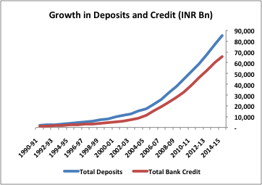

- Comparative indicators with other major banking economies: Despite the developments of the past two and a half decades, the Indian banking sector still lags other major economies. The loan-to-deposits ratio currently stands at 77%, compared to 84% in China and over 100% in both the United States in Singapore, while the loan-to-GDP ratio stands at 61%, compared to 64% in the United States and almost 150% in China and Singapore. The total assets in the banking system are comparatively lower at USD 1,877 billion, compared to USD 16,025 billion in the United States and USD 31,390 billion in China. This translates to USD 1,288 per capita in India, USD 34,367 in the United States and USD 13,312 in China (Appendices: Table 4).

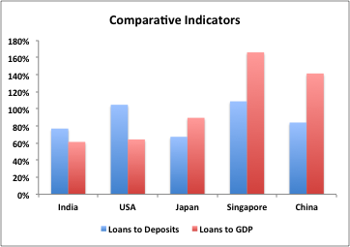

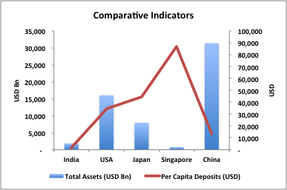

- Performance of Public Banks: While the number of banks in the public sector remained constant at 20 from 2008-09 to 2012-13, the business per employee increased from INR 78 to INR 142 (average of over 450,000 employees). However, the sector has been suffering from the prevalence of high interest rates, policy paralysis / inflationary pressures and the requirements of Priority Sector Lending, with the Net Interest Margin (NIM) largely constant at 2.3% from 2008-09 to 2012-13, and the Return on Assets (RoA) dropping from 1% to 0.74% over the same period. The Cost of Funds (CoF) for banks grew significantly as banks face increasing competition for new customers, from a low of 4.93% in 2010-11 to 6.39% in 2012-13. Net NPAs ballooned over this time, from 0.68% to 2%. (Refer to charts below) (Appendices: Table 5)
- Performance of Private Banks: The private sector shrunk marginally from 22 banks in 2008-09 to 20 in 2012-13, while the business per employee grew from INR 68 (around 200,000 employees) to INR 94 (over 250,000 employees) in the same period. Private banks displayed improvement across all metrics, in spite of an increasing CoF, with the NIM growing from 2.86% in 2008-09 to 3.22% in 2012-13, RoA growing from 1.13% to 1.63%, and Net NPAs dropping from 1.29 % to 0.52% over the same period. (Refer to charts below) (Appendices: Table 6)
- Performance of Foreign Banks: The number of foreign banks in India grew from 31 in 2008-09 to 43 in 2012-13, as the RBI opens the system up to more players. This sector was also the most efficient in the banking industry, with the business per employee growing from INR 129 in 2008-09 to INR 217 in 2012-13, while the number of employees have actually dropped from around 30,000 to around 25,000 over the same time. However, the performance of foreign banks has been a mixed bag of sorts, with the NIM deteriorating from 4.33% in 2008-09 to 3.89% in 2012-13 and a more-or-less constant RoA at around 1.9%, while the CoF dropped from 4.46% to 4.05% and Net NPAs improved from 1.81% to 1.01% during this period. (Refer to charts below) (Appendices: Table 7)
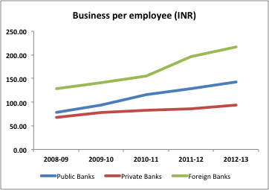

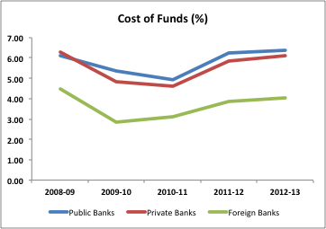

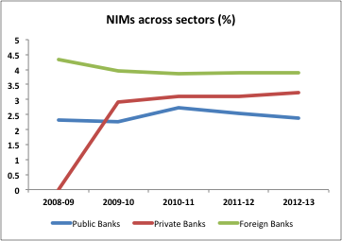

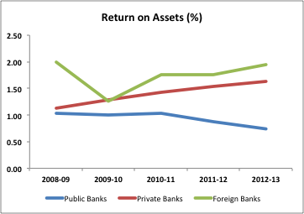

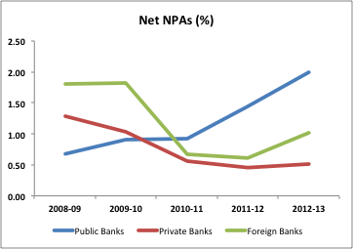

Appendices
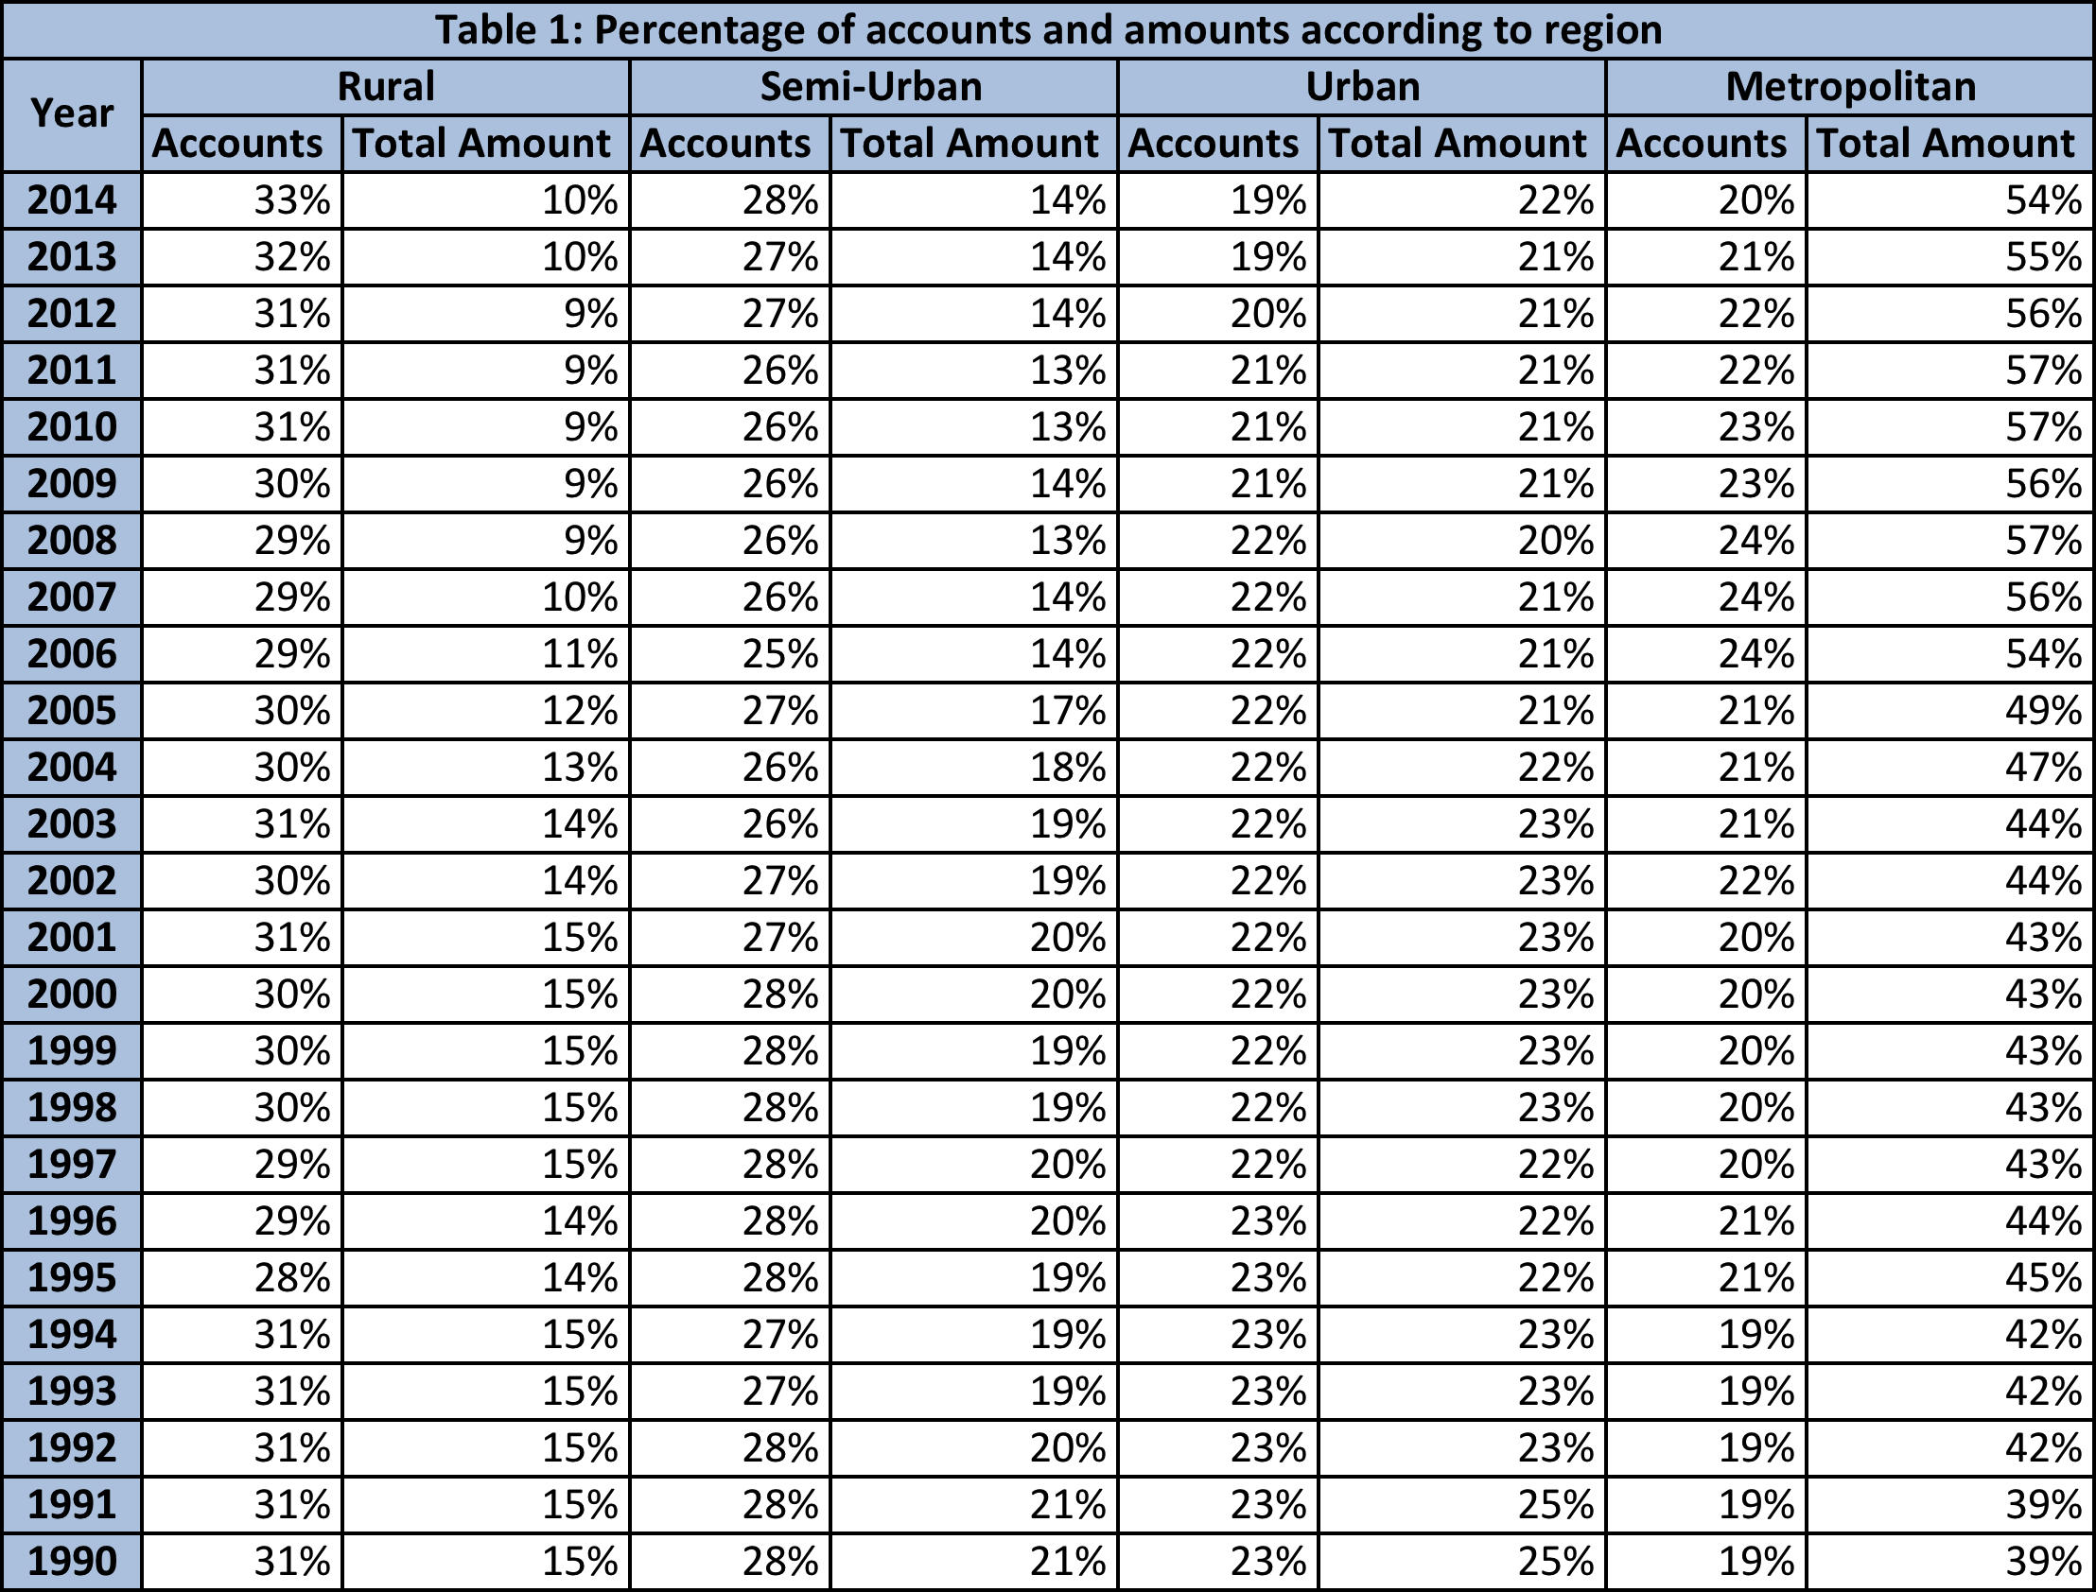
(Source: RBI)

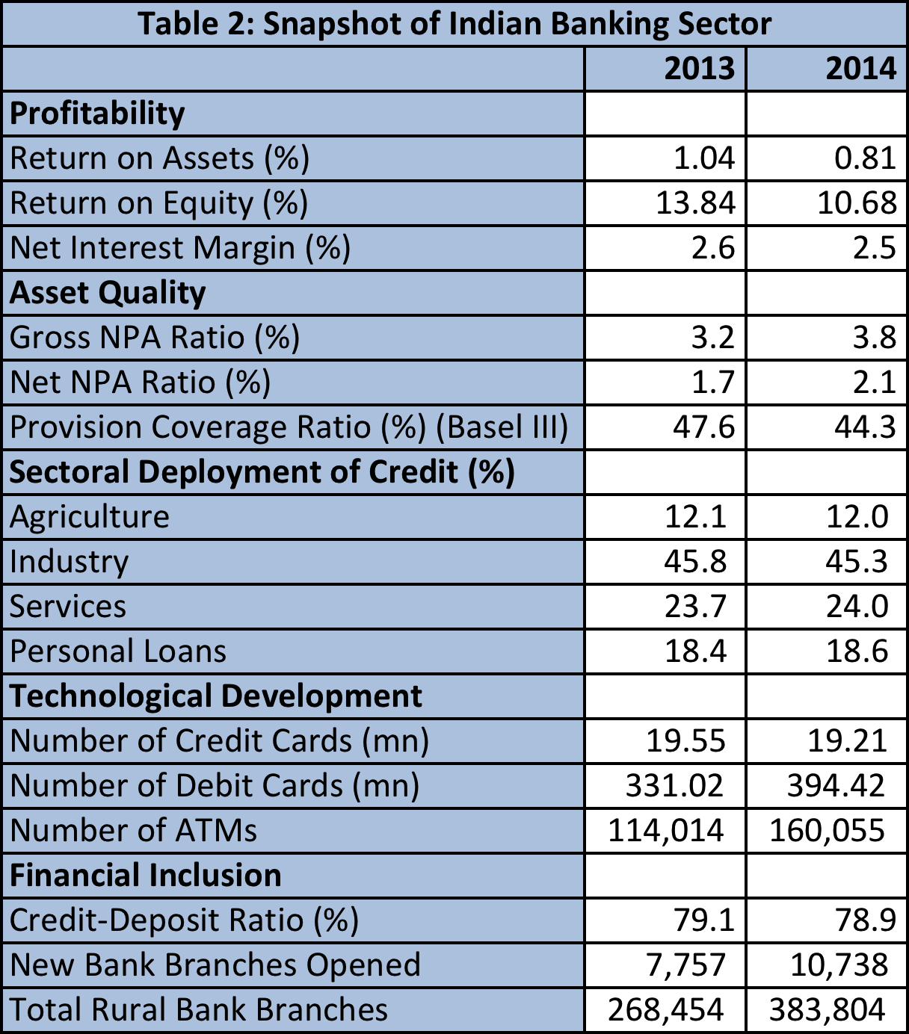
(Source: RBI)

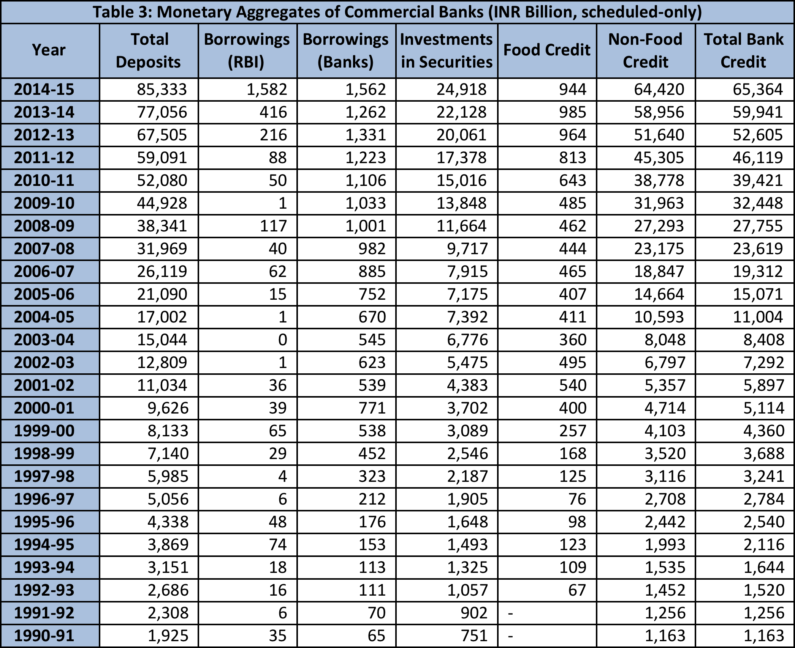
(Source: RBI)

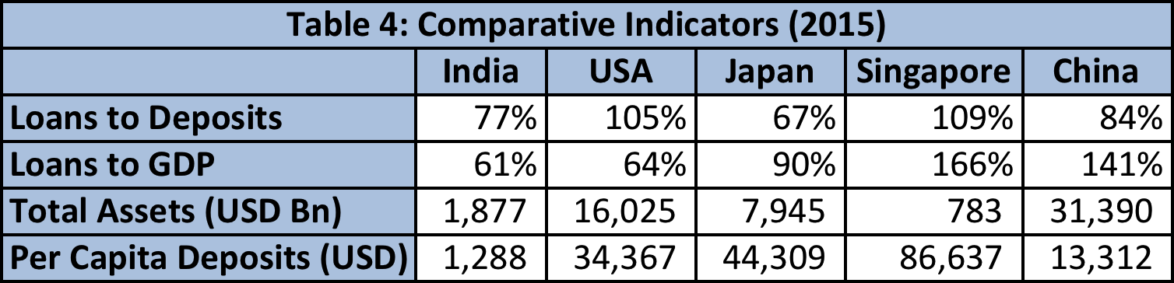
(Source: Business Monitor International)

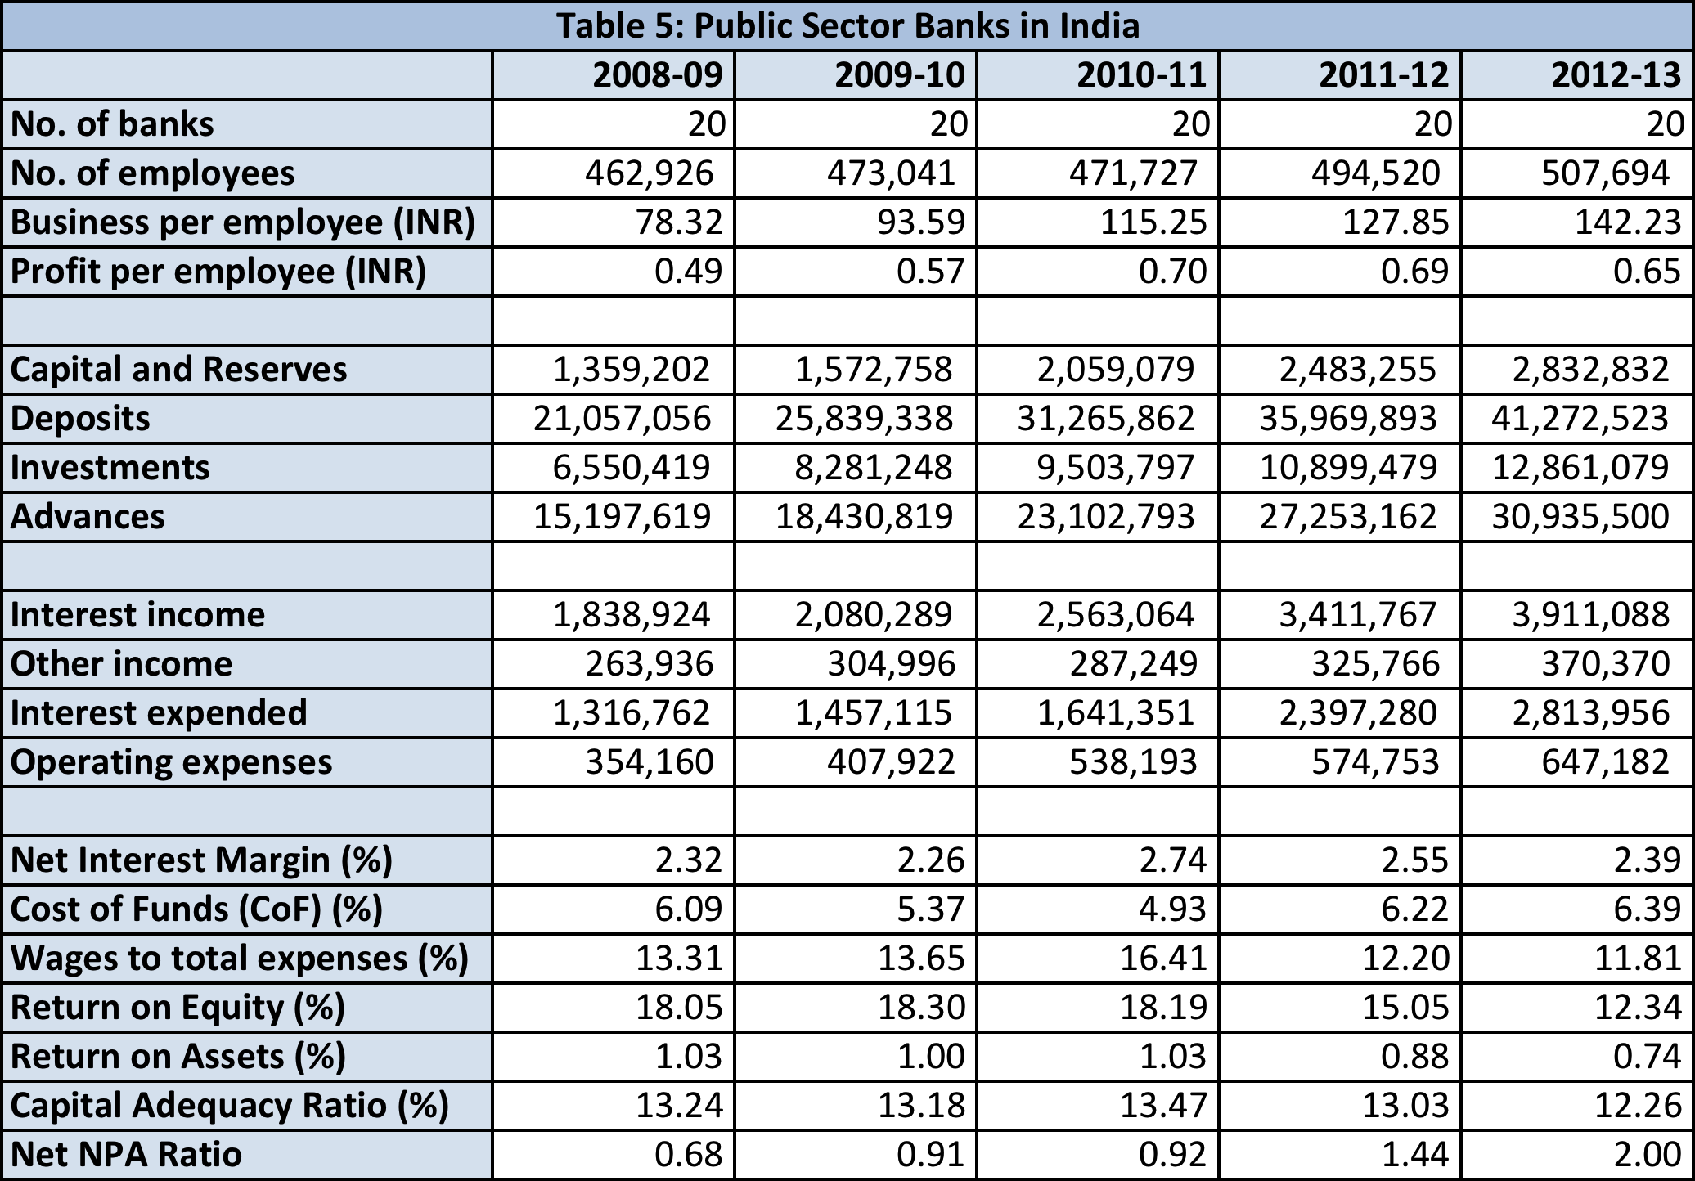
(Source: RBI)

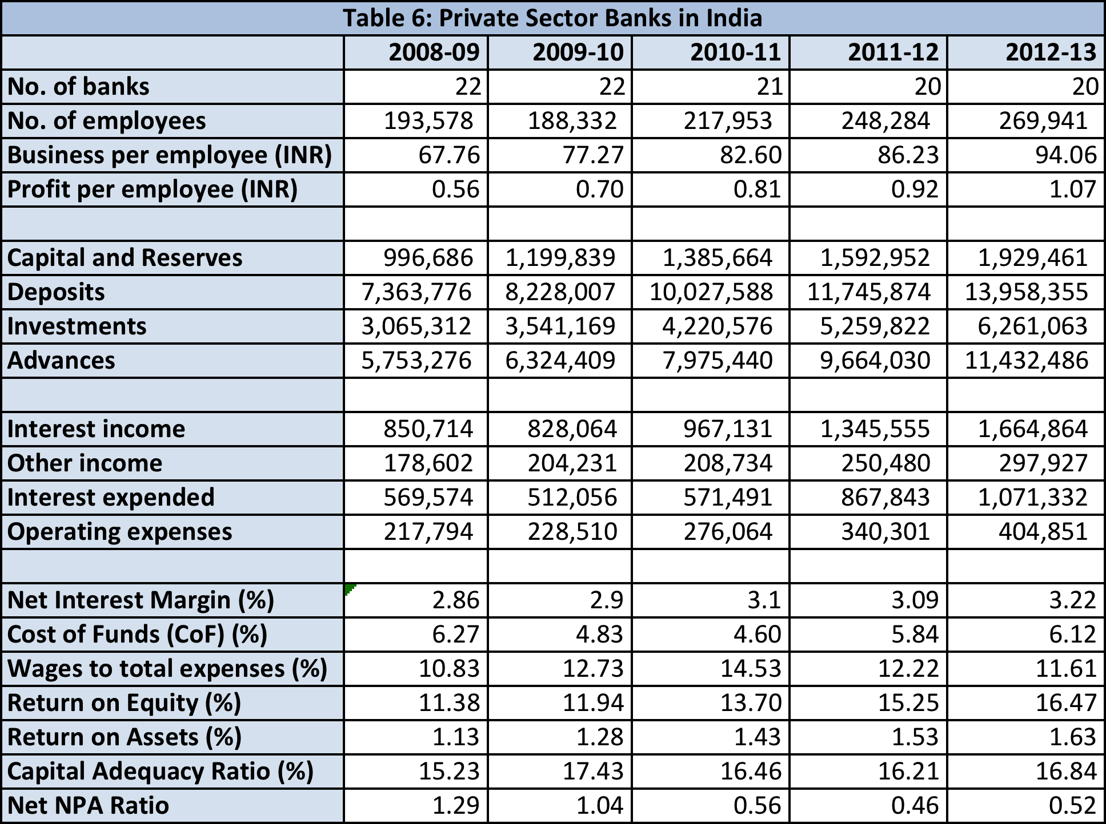
(Source: RBI)

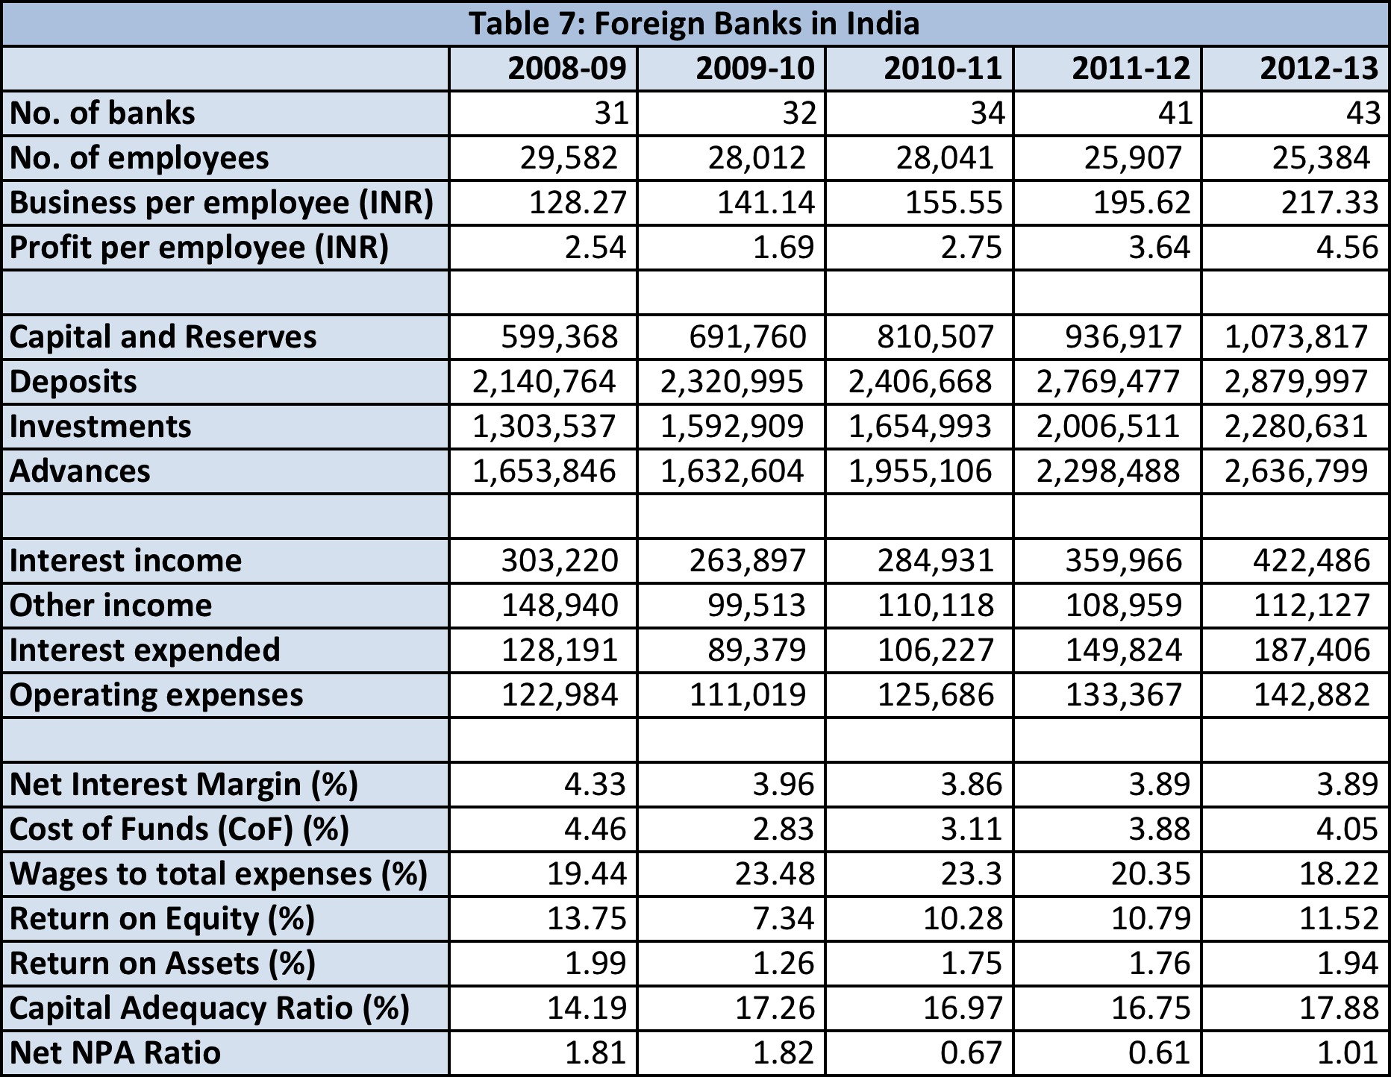
(Source: RBI)

Sources
- RBI (www.rbi.org.in)
- ‘A Profile of Banks’, 2012-13, RBI
- ‘India Commercial Banking Report’, Q22015, Business Monitor International
- ‘Banks in India’, October 2014, MarketLine Industry Profile
- ‘Entry, Concentration and the Process of Competition: Early Days of Deregulating Private Banking Industry in India’, K V Bhanu Murthy and Ashis Taru Deb, IUP Journal of Applied Finance
- ‘India names systemically important banks’, Narae Kim, GlobalCapital

