Capital Markets in India

Table of Contents
Introduction and History 2
I. Debt Markets 3
II. Equity Markets 7
III. Derivatives Markets 11
IV. Mutual Funds 13
Appendices 14
Sources 23

Introduction and History
The Indian capital markets, as was the case with the rest of the economy, were direct beneficiaries of the New Economic Policy (NEP) of 1991 and the subsequent unshackling of the Indian economic and financial system through the last two-and-a-half decades. There have been a number of reforms instituted in the capital markets from 1991 until now, the main among which are:
- Establishing the market regulator: The onus and responsibilities of monitoring the securities market in India were transferred to the Securities and Exchange Board of India (SEBI), which was established as an independent statutory authority for regulating the stock exchanges and for supervising the major players (including brokers, underwriters, merchant bankers and mutual funds).
- Creation of a National Stock Exchange (NSE): The NSE was created in 1992, as the first demutualized electronic exchange in India. Prior to this, all stock trades were handled in physical form by the Bombay Stock Exchange (BSE), which was owned, controlled and managed by brokers. The NSE also provided the first fully-automatic, screen-based electronic trading system to investors across the country, and facilitated the introduction of the first depositories in India – National Securities Depository Limited (NSDL) and Central Depository Services Limited (CDSL).
- Setting-up a national clearing and settlement house: To reduce counterparty risks in the capital markets, NSE setup the Clearing Corporation of India Limited (CCIL), which commenced operations in 1996, with twin objectives of improving the efficiency in the transaction process and to provide a guaranteed settlement facility for transactions in the government securities, money and foreign exchange markets.
- Rationalization of the trading cycle: Prior to the NEP, the trading cycle for stocks used to take 14 – 30 days and the settlement took another fortnight. The trading cycle was reduced to one week through the NEP. In 2001, rolling settlements were introduced, reducing the settlement period first to T+5 and then to T+3 days. From 2003, the settlement cycle stands at T+2 days.
- Staggered launches of derivative products: Before 1995, the capital markets in India banned all trading in options on securities. However, in 1995, hedging, speculation and arbitrage activities were introduced into the legal framework, and trading in equity derivatives took off in the year 2000, with the first index futures being introduced by the NSE. In 2008, the NSE introduced trading in currency futures (the USD-INR pair was the first one allowed), and, in 2009, interest rate futures were launched in the Indian capital markets.
- Bringing Indian stock issues to global markets: The NEP and subsequent economic reforms also permitted Indian companies to raise foreign capital through the issue of ADRs, GDRs, FCCBs and ECBs. Additionally, FIIs were allowed, for the first time, to invest in all the instruments in the capital markets. Lastly, Indian stock exchanges were allowed to setup trading platforms in other countries.

I. Debt Markets
Prior to the reforms introduced by the NEP in 1991, the Indian debt markets possessed a number of negative attributes, namely: a) low liquidity, b) underdeveloped markets (not enough participants), c) pricing (and issue) controls, d) near-monopoly of state-run participants and insurmountable barriers to entry for private players, and e) high transaction costs (primarily because of all the factors above).
However, since the early 1990s, the Indian debt markets have reaped the rewards of financial reforms and increased significantly in trading volumes, liquidity, number of participants, and in the types of issued and traded. Additionally, market information and transparency have increased exponentially, allowing participants with trading platforms on par with any other developed debt markets.

The debt market in India can be broadly divided into three parts (Figure 1):
- Sovereign debt: the dominant player in the overall market, this consists of all government issues (central and state), mainly through Government Securities (Treasury Bonds) and Treasury Bills.
- Public sector debt: this consists of all instruments issued by public sector enterprises, including public sector banks, industries and financial institutions, such as corporate bonds, commercial papers, certificates of deposit and debentures, among others.
- Private sector debt: this largely consists of instruments issued by private sector companies, along with banks and financial institutions, such as bonds, commercial papers, debentures and securitized debt, among others.
The major participants in the debt markets, in order of volumes traded, are: foreign banks, Indian banks, primary dealers and institutions (financial institutions, mutual funds and corporates). The total number of trading members has increased substantially over the two decades, primarily because of the reforms instituted in the NEP and by subsequent governments, from 3,921 in 1994-95 to 432,218 in 2014-15. (Appendices: Table 1)
Additional Developments in the Indian debt markets after the NEP:
- Government securities (Treasury Bonds and Bills)
- Primary Dealers (PDs): a system of PDs was first introduced in 1995, primarily to function as underwriters and bidders in the primary market (by supporting the auction system of new government issues), and as market makers in the secondary markets (by facilitating trading).
- Wholesale Debt Markets (WDM) segment in the National Stock Exchange (NSE): The WDM segment was introduced as the first screen-based trading facility for the debt market in 1994. This has now been replaced with a more advanced Negotiated Trade Reporting Platform that covers almost all the instruments traded in the debt markets.
- Negotiated Dealing System (NDS) and Negotiated Dealing System – Order Matching system (NDS-OM): Prior to 2002, the government securities market in India was a phone-based market, with settlements handled physically through ledger forms and paper-check payments. The RBI initiated the change toward automated processes in 2002, when it introduced the NDS, which allowed primary market participants to electronically submit issue bids and receive allotments. To facilitate electronic trading and settlement in the secondary market, the RBI introduced the NDS-OM system in 2005. The NDS-OM is owned by the RBI and operated by the CCIL and has captured over 80% of the secondary trading volume in government securities.
- Product innovations: Some of the most important products introduced since the NEP include Zero Coupon Bonds, Floating Rate Bonds, STRIPS, Bonds with Call and Put options, Inflation-Indexed Bonds, Capital-Indexed Bonds, Interest Futures, Interest Rate Swaps / Forward Rate Agreement and Credit Default Swaps.

- Corporate bonds
There are a number of key developments that have helped in greatly improving the transparency and tradability of corporate paper, the main among which are:
- Demateralization of holdings and the compulsory reporting of trade by the Stock Exchange Board of India (SEBI), which is the overseer for the corporate bond market.
- Formalized documentation requirements for private placements, which form the bulk of trades in India.
- Developing local credit agencies to provide adequate information to investors. Currently, the main credit agencies in India are CRISIL, CARE, ICRA and Fitch (India).
- Simplifying listing requirements for corporate paper.
Market Trends
Government Securities (T-Bonds and T-Bills)
The biggest positive that has arisen from the directed reforms of the last two decades is the emergence of a reliable and market-responsive yield curve in the government securities market. Although the secondary debt market is still highly illiquid and dominated by a few players, the yields in the secondary markets have begun to track the yields in the primary markets (ruled by the auction system). Thus, the sovereign yield curve has slowly but reliably emerged as a benchmark for pricing non-governmental issues.
The Indian debt markets are dominated by government securities (both bonds and bills), which form nearly three-quarters of the total trades in the WDM segment. (Appendices: Table 2) Overall, the turnover in government bonds has grown from INR 2,833 billion in 1998-99 to INR 183,025 billion in 2014-15, at a sustained CAGR of nearly 28% during this period.
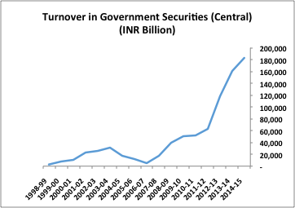
The 91-day T-Bill is the most traded near-money instrument, accounting for more than half the total treasury bill trades, with the 364-Day Bill accounting for nearly a third. The turnover in the 91-Day and the 364-Day T-Bills has grown at a CAGR of nearly 20% and 17.5%, respectively, over 1998 – 2015. (Appendices: Table 2)
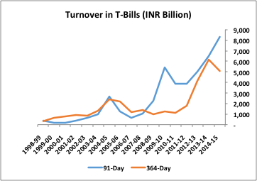
The total market capitalization of the WDM segment has grown substantially from INR 1,582 billion in 1994-95 to INR 57,892 billion currently, representing a CAGR of almost 18%. The average size of the trades executed on the WDM has also increased significantly, from 0.07 billion in 1994-95 to nearly 0.40 billion currently. (Appendices: Table 3)
Corporate Bonds
The corporate bond market in India, although growing consistently and being supported by well-developed infrastructure, still lags significantly behind the equity markets. Additionally, corporate issues are characterized by a handful of players (mainly private placements), are largely driven by arbitrage and are still substantially illiquid.
Thus, of the total trades on the WDM, corporate paper forms less than 10%. However, the actual volume of trades has increased rapidly over 2011-2015, from INR 1,936 billion in 2011-12 to INR 8,866 billion in 2014-15, at a CAGR of over 45%. (Appendices: Table 4)

II. Equity Markets
The equity market in India was first established in 1875 with the formation of the BSE (it was known as the “Native Share and Stock Brokers’ Association” at inception). However, for most that twentieth century, the equity markets in India were characterized by illiquidity, broker control, and plagued by insider trading scams and regulatory issues. The real reforms in the stock bourses began after the NEP, when the NSE was established in 1992. Currently, the NSE commands the lion’s share of trades – almost 75% in the spot market and over 95% in derivative trading. Although the BSE has nearly three times the number of listed firms compared to the NSE, less than ten percent of those are traded regularly, while the bulk are highly illiquid counters.
Trading mechanisms: Both the exchanges use what is known as an ‘open electronic limit order book’, wherein orders are matched automatically and anonymously by the system, depending on the limits. Thus, all buyers and sellers remain anonymous, and this system ensures greater transparency overall.
Trading and settlement cycle: The trading cycle on the Indian bourses is one business week, and the spot markets follow a T+2 days rolling settlement cycle. Additionally, all trades are now compulsorily dematerialized and all counterparty risk is assumed by the two main clearing houses, NSDL and CDSL.
Trading hours: The regular trading session on both the bourses is from 0930 IST to 1530 IST, Mondays through Fridays (except trading holidays).
Major indexes on the BSE and the NSE:
NSE
The CNX Nifty: The main index of the NSE, this consists of 50 of the largest and most liquid stocks from 13 economic sectors, and represents nearly two-thirds of the free-float market capitalization of the total stocks listed on the bourse. Other important indices on the NSE include :
- The CNX Nifty Junior (which consists of the next 50 most liquid stocks on the NSE, representing around 12% of the free-float market cap).
- The CNX Midcap (representing almost 14% of the free-float market cap).
- The CNX Smallcap (comprising of 100 of the smallest, frequently-traded companies, and representing almost 3% of the free-float market-cap).
- The CNX 500 (a broad-based benchmark representing almost 96% of the free-float market cap).
BSE
The S&P BSE Sensex: The main index of the BSE, this consists of 30 of the largest and most liquid stocks in India, and represents almost half of the bourse’s free-float market capitalization. Other important indices on the BSE include:
- The S&P BSE 100 (which consists of the top 100 companies listed on the BSE, according to market cap and liquidity of their counters).
- The S&P BSE 200 (which consists of the top 200 companies listed on the BSE, according to market cap and liquidity of their counters).
Foreign Investments in India:
The two main routes for foreign players to invest in Indian companies are:
- Foreign Direct Investment (FDI): Any investment in a company that exceeds 10% of its paid-up equity capital is classified as an FDI. Currently, 100% FDI is allowed in a number of sectors, with 74% cap on private banks, and 49% on defense companies, insurance companies, clearing corporations, stocks exchanges, depositories and commodity exchanges.
- Foreign Institutional Investors (FII) or Foreign Portfolio Investors (FPI): Investors that purchase the stock in a company, up to a maximum 10% of its paid-up equity capital per foreign entity, through the stock market route. Currently, India does not allow individual (retail) foreign investors to participate on the domestic bourses. They can, however, subscribe to ADR / GDR issues for participating companies, or invest in India-specific mutual funds. The net investment by FIIs has increased from INR 0.04 billion in 1992-93 to INR 1,102 billion in 2014-15. (Appendices: Table 5)
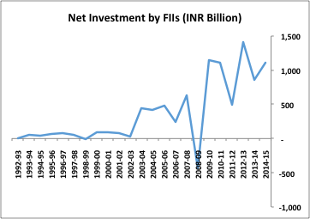
The most significant reform regarding foreign investments in Indian companies has been the removal of a cap that served as a ‘limit within the limit’, and which defined a further cap within the 100% FDI limit, depending on the type of investment (FDI or FII / FPI). This has been replaced by a ‘composite cap’, which makes no distinction between the different routes used by foreign investors and, instead, merely caps the overall investment depending on the sector (with two exceptions: defense and banking).

Shareholding Patterns
One of the peculiarities of listed Indian companies is the nature of the shareholding – the average promoter holding stands at almost 50%, leaving only half the total paid-up equity capital of a company liquid for institutional and retail investors. Furthermore, retail or individual holdings are, on an average, at a low 12%, limiting the trading participation across investor classes. The average foreign participation in Indian companies is around 4%, with Service-based industries attracting the highest chunk at 10% of their overall equity capital. (Appendices: Table 6)
Funds Mobilization in the Primary Markets
The nature of funds raised in the primary markets by Indian companies has undergone a fundamental shift over the past few years. As retail participation has faded in the IPO market, more companies are resorting to Qualified Institutional Placements (QIPs) and Preferential Allotments. As a result, the amount raised through QIPs has increased from INR 21.54 billion in 2011-12 to INR 280.14 billion in 2014-15, while that raised through preferential allotments has increased from INR 228.86 billion in 2011-12 to INR 535.23 billion in 2013-14 (it has dipped to INR 194.56 billion in 2014-15). The overall IPO market in India remains depressed, with the total volume dropping from INR 62.89 billion in 2012-13 to INR 14.62 billion in 2014-15. Lastly, although the total funds mobilized increased from INR 665.03 billion in 2011-12 to INR 1,027.13 in 2013-14, they have fallen drastically to INR 628.08 billion in 2014-15. (Appendices: Table 7)
Market Trends
The Indian bourses have been direct beneficiaries of the NEP and subsequent economic reforms – turnover on the NSE has increased from a mere INR 18 billion in 1994-95 (the first year of trading) to INR 43,258 billion in 2014-15, representing a CAGR of almost 45%.
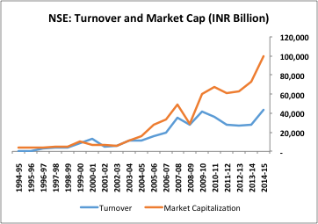

Although the BSE was the first exchange in India, it has lagged the NSE in no insubstantial terms, growing in turnover from INR 677 billion in 1994-95 to INR 5,217 billion in 2013-14, at a CAGR of 11%. Additionally, the BSE has been steadily losing turnover after the global financial crisis, as more and more participants switch to trading on the NSE. In terms of overall market capitalization, although the BSE nominally outpaces the NSE, at INR 101,493 billion compared to INR 99,301 billion in 2014-15, a large part of this is from illiquid counters in the BSE and from a number of the so-called ‘Z-Category’ shares which are highly-speculative, junk-grade counters. (Appendices: Table 8)
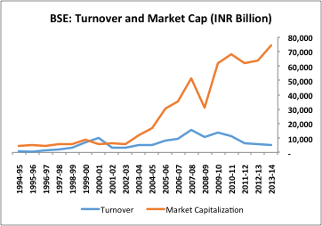

III. Derivatives Markets
History
Derivatives trading in India began as early as 1875, when the Bombay Cotton Trade Association introduced futures contracts. However, in 1952, the socialist government of the time banned all speculative trading (including futures and options), a ban that stayed in place until the late 1990s – early 2000s. Although the NEP flirted with the idea of reintroducing futures and forwards in the late 1990s, this did not actually happen until 2000, when SEBI formally allowed the NSE and BSE to commence trading in index futures. Thus, in June 2000, both the NSE and the BSE introduced the first index futures on the Indian bourses. This was followed by the introduction of index options, and stock futures and options in 2001. In 2008, currency futures trading commenced on the NSE, followed by interest rate futures in 2009.
Principal Derivative Products
NSE
- Equity Derivatives: Index Futures and Options based on the CNX Nifty, CNX-IT, Bank NIFTY, CNX-Infrastructure, CNX-PSE (Public Sector Enterprise) and the Nifty Midcap 50; Options and Futures in individual securities (Options for 163 securities allowed by SEBI).
- Currency Derivatives: Four currency pairs currently allowed in Futures – USD/INR, EUR/INR, GBP/INR and JPY/INR; Options allowed only in USD/INR.
- Interest Rate Futures: Based on 6-year, 10-year and 30-year Government Bonds, and on 91-Day Treasury Bill.
BSE
- Equity Derivatives: Index Futures and Options based on the S&P BSE Sensex, BSE TECK (technology stocks), BSE FMCG, BSE Metal, BSE Bankex, and BSE Oil & Gas; Options and Futures in individual securities (Options on 31 individual stocks).
- Currency Derivatives: One pair in Futures – USD/INR.
Market Trends
Equity Derivatives
Trading in equity derivatives has, in a sense, truly taken-off since its start in 2000, with the total turnover on the NSE increasing from INR 24 billion in 2000-01 to INR 560,258 billion in2014-15, at an astounding CAGR of 96%. The total turnover on the BSE, although trailing the NSE in sheer volume, has followed suit, growing at a CAGR of 87% from INR 17 billion in 2000-01 to INR 203,627 in 2014-15. In terms of the type of instruments traded on the exchanges, the BSE is dominated by Index Options, which form almost 99% of its total turnover. In comparison, the NSE has a more diverse composition, with Index Options forming 71% of its total turnover, while Stock Options, Index Futures and Stock Options form 15%, 7% and 6%, respectively. (Appendices: Table 9)
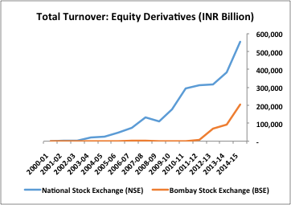
Currency Derivatives and Interest Rate Futures
The total turnover in currency derivatives on the NSE has increased from INR 1,623 billion in 2008-09 to INR 30,239 billion in 2014-15, at an impressive CAGR of 52%. Interest Rate Futures, recent inductee into the NSE’s list of instruments, have also increased significantly, from INR 30 billion in 2009-10 to INR 4,216 billion in 2014-15. (Appendices: Table 10)
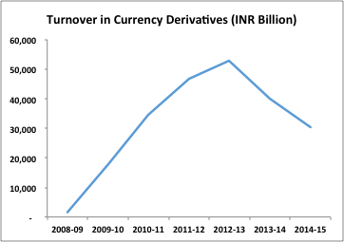
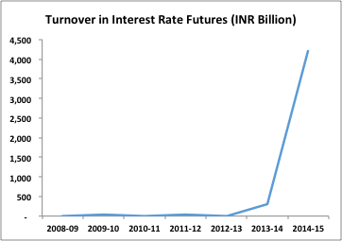

IV. Mutual Funds
The development of the mutual fund industry in India can be divided into three main phases:
Phase I (1964 – 1987): The mutual fund industry was established in 1963 with the set-up of the Unit Trust of India (UTI), a public sector undertaking owned jointly by the central government and the RBI. For the entirety of this phase, UTI was the sole player in the industry.
Phase II (1987 – 1993): The second phase was characterized by the entry of other public sector mutual funds setup by public sector banks and insurance companies. During this period, the AUM of the industry grew from INR 67 billion to INR 470 billion.
Phase III (1993 –): This phase was marked by a fundamental transformation in the mutual fund industry in India, with the NEP opening the entire sector up to private sector companies (both domestic and foreign).
Market Trends
The assets mobilized by mutual funds every year have increased substantially from 1993 until now, growing from INR 130 billion to a high of INR 1,587 billion in 2007-08. However, following the global financial crisis, these declined substantially to INR 242 billion 2008-09, before recovering to INR 749 billion in 2012-13. (Appendices: Table 11) Currently, there are around 45 mutual fund organizations in India and over 2,000 schemes, with total AUM of INR 10,828 billion, representing a CAGR of over 14% from 1997 – 2015. (Appendices: Table 12)
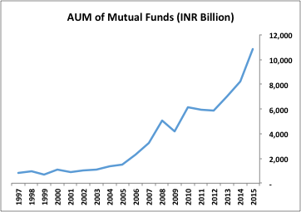

Appendices
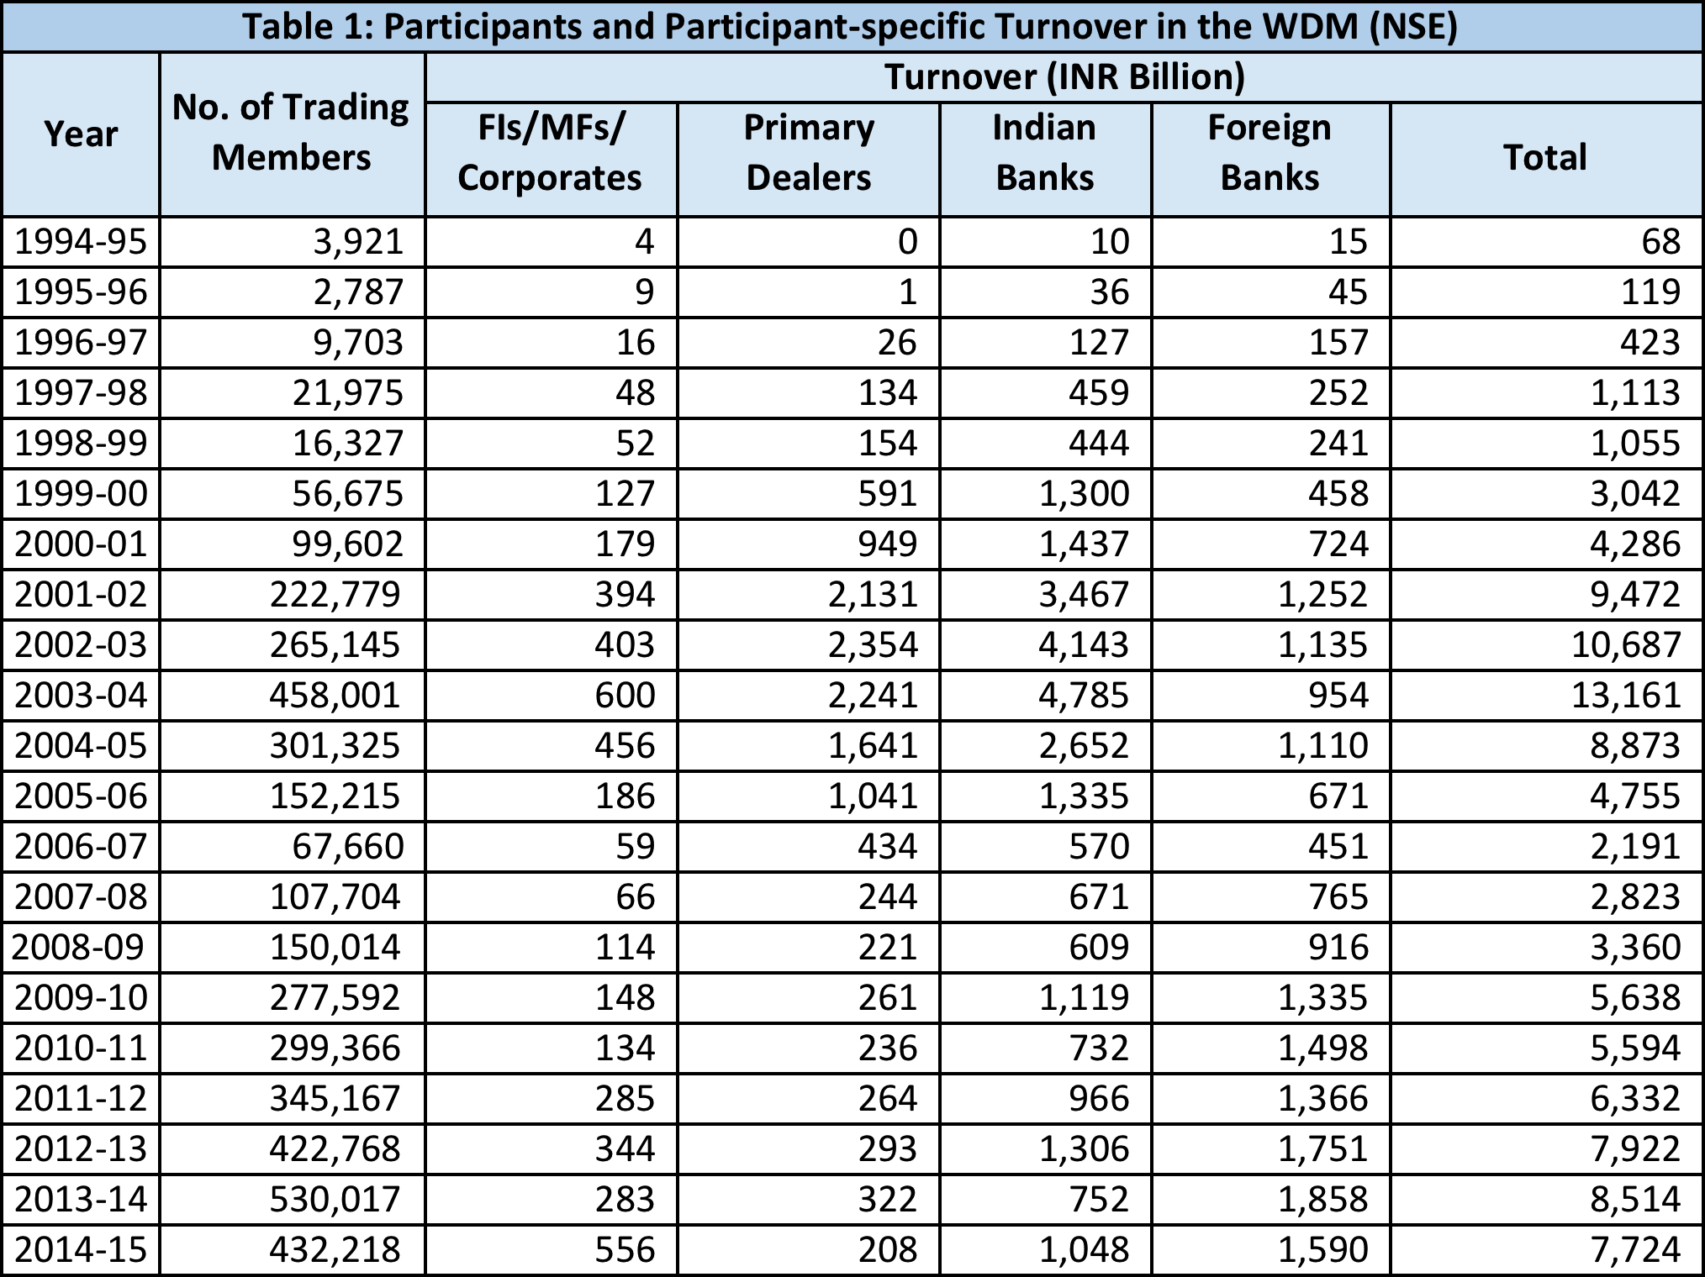
(Source: NSE, RBI)
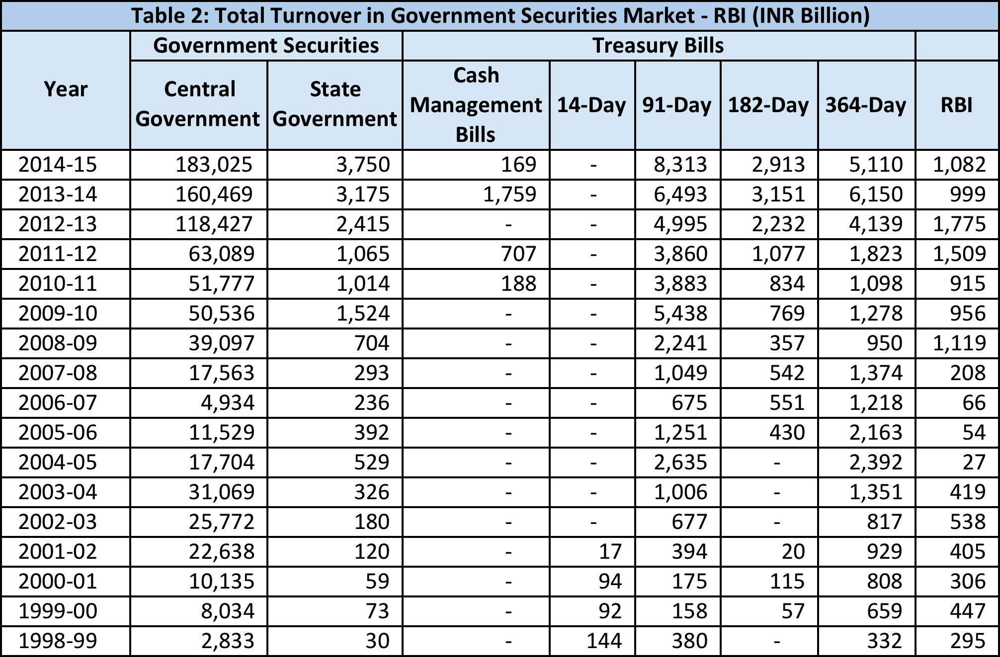
(Source: RBI)
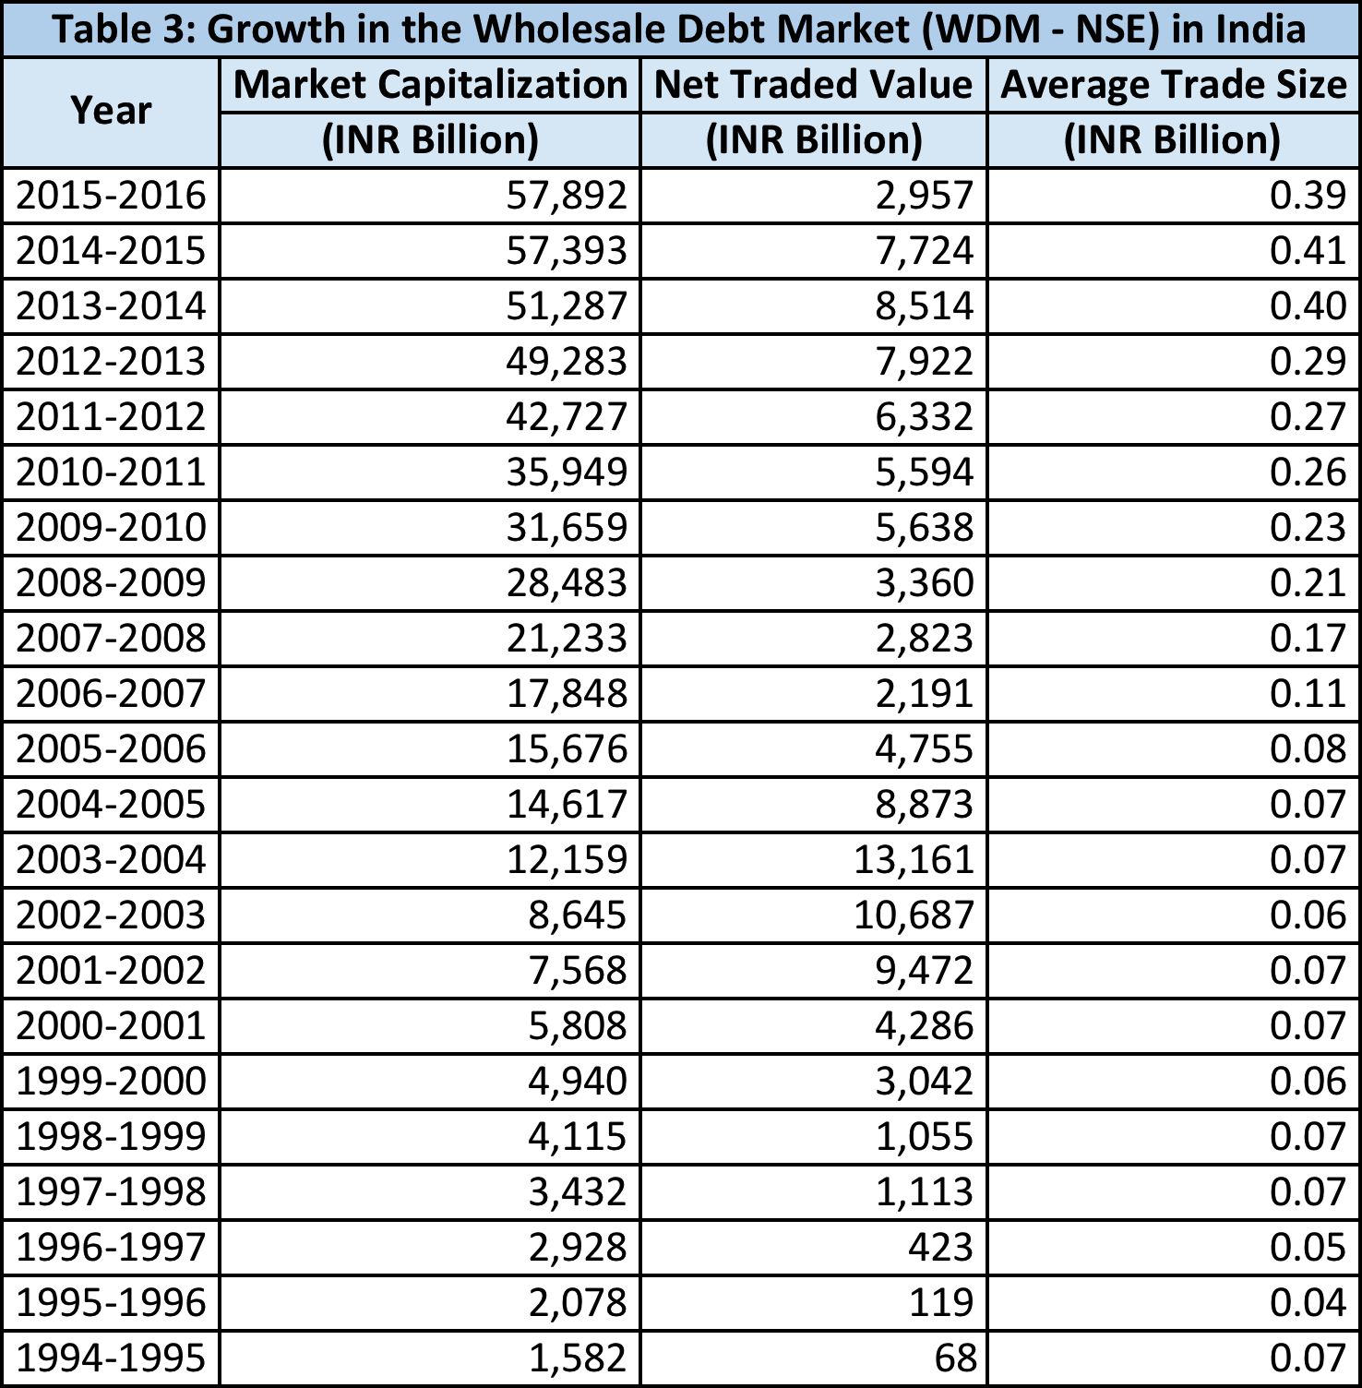
(Source: NSE, RBI)

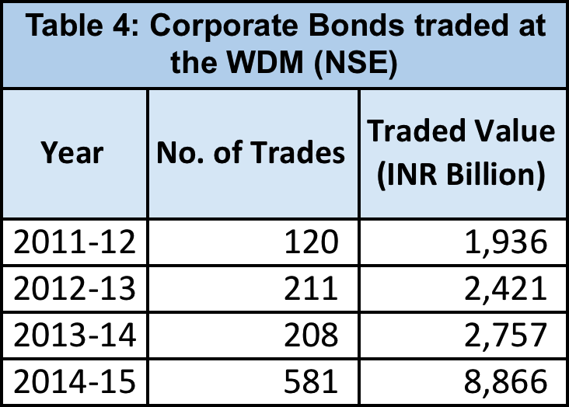
(Source: NSE, RBI)
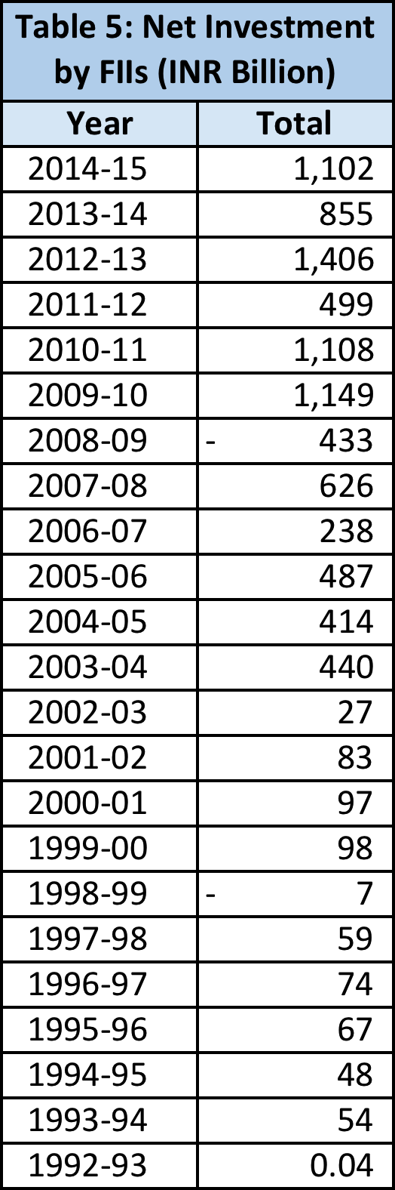
(Source: RBI)

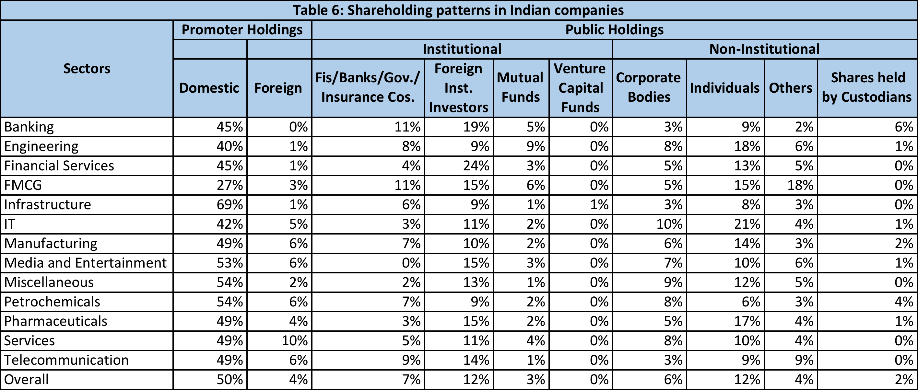
(Source: RBI, NSE)
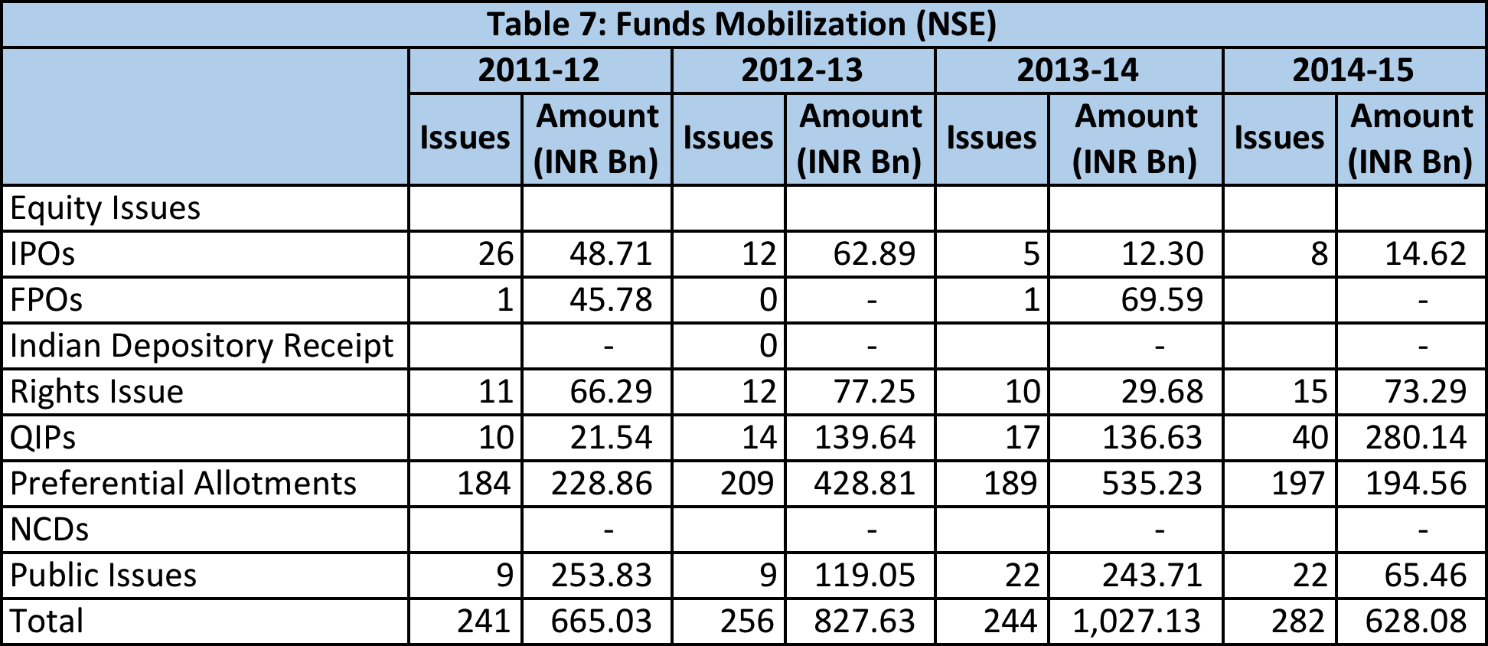
(Source: NSE)
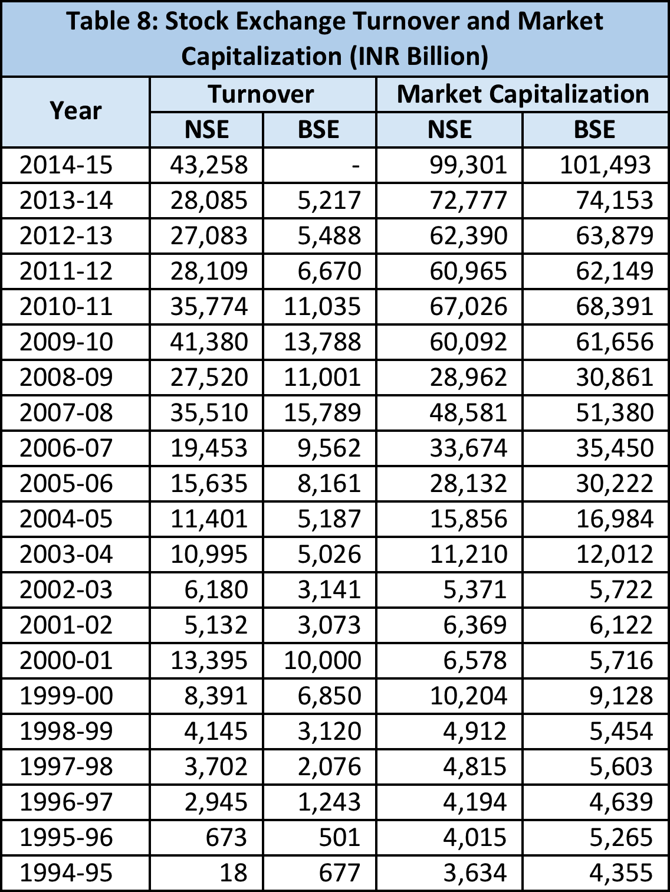
(Source: NSE, BSE)

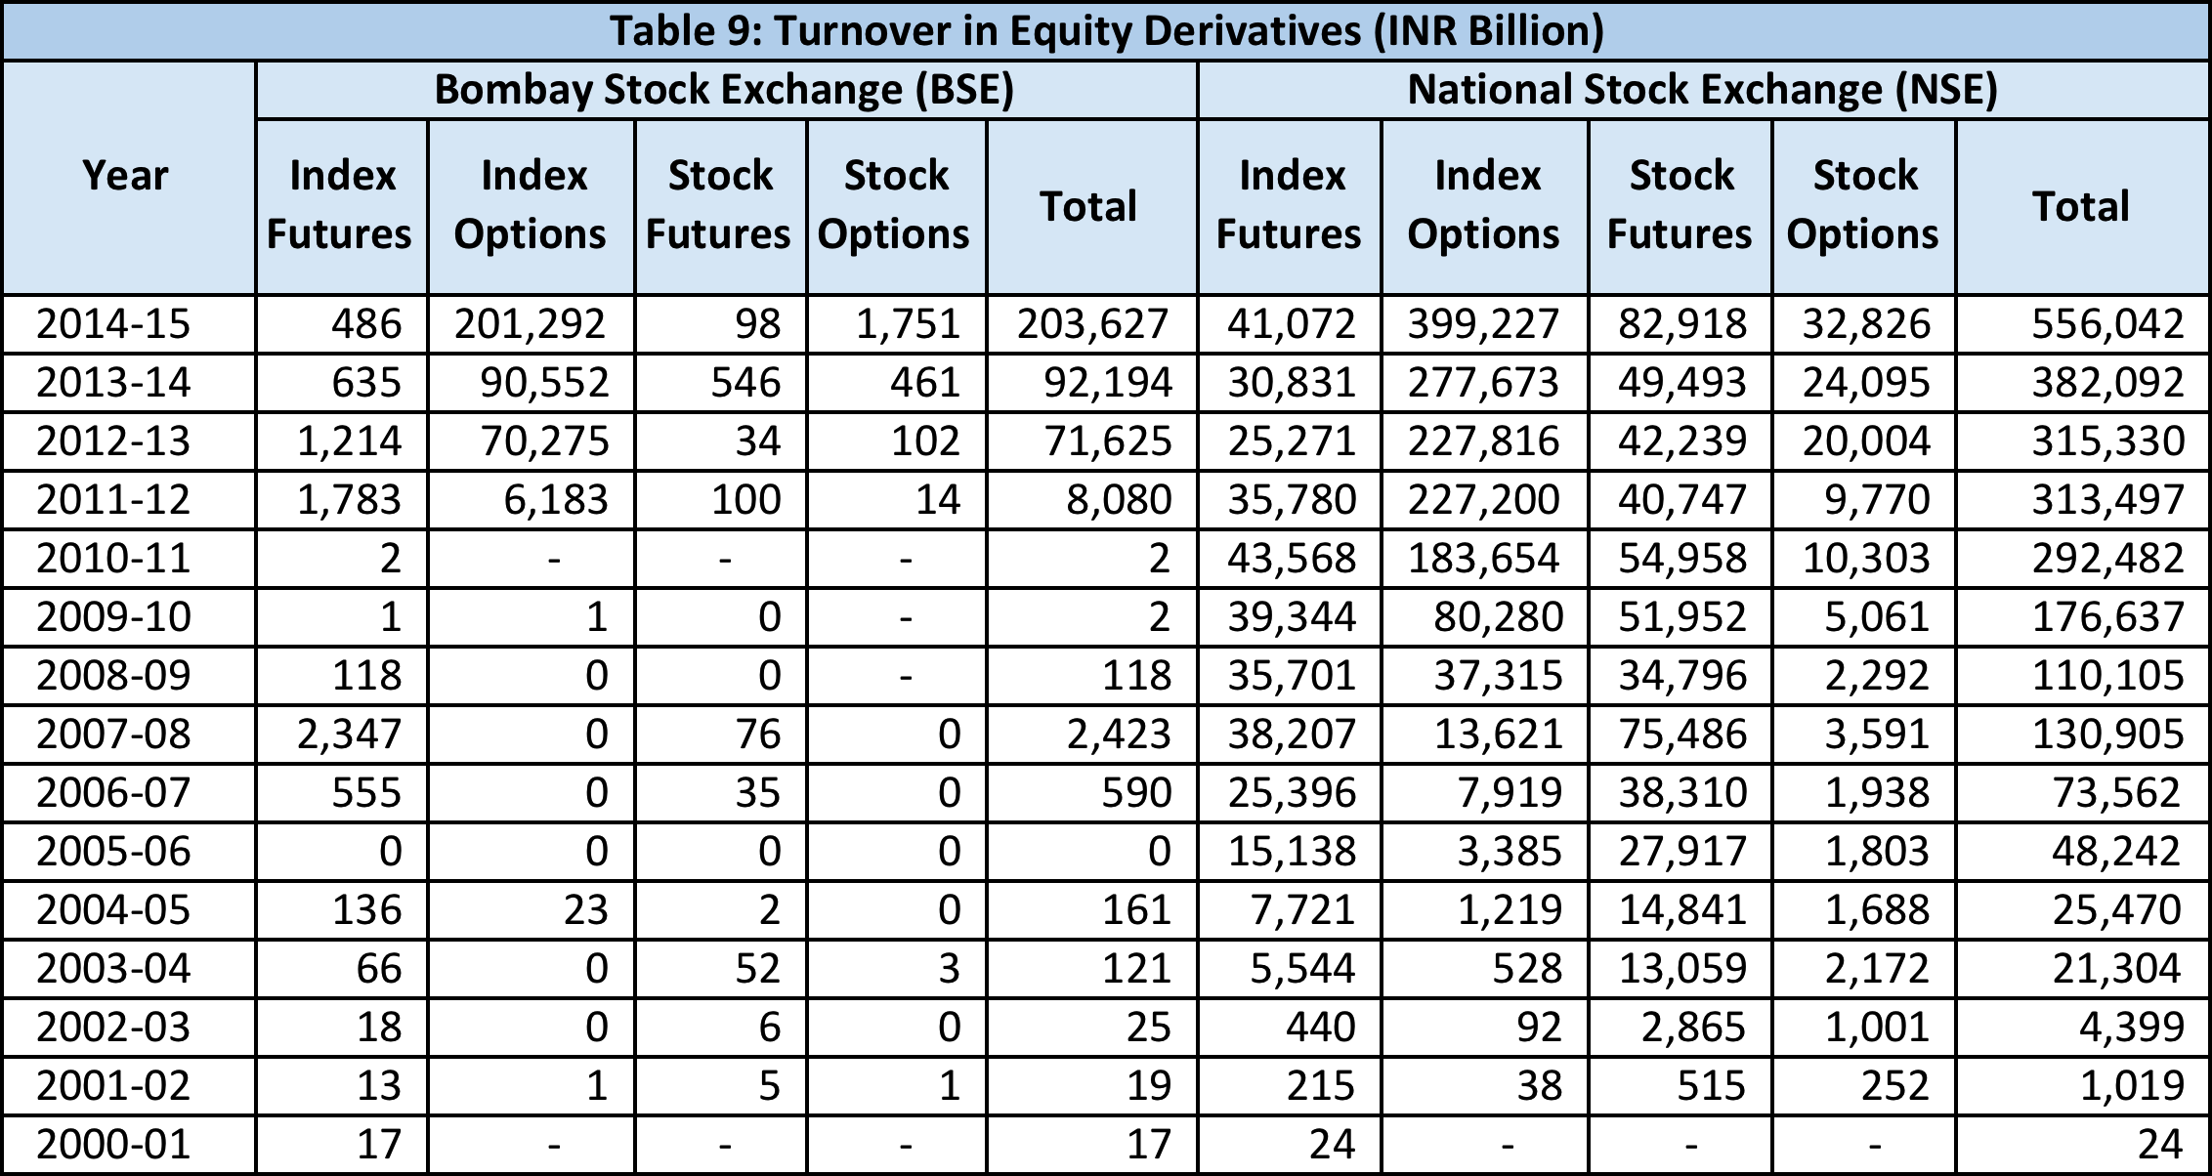
(Source: NSE, BSE)
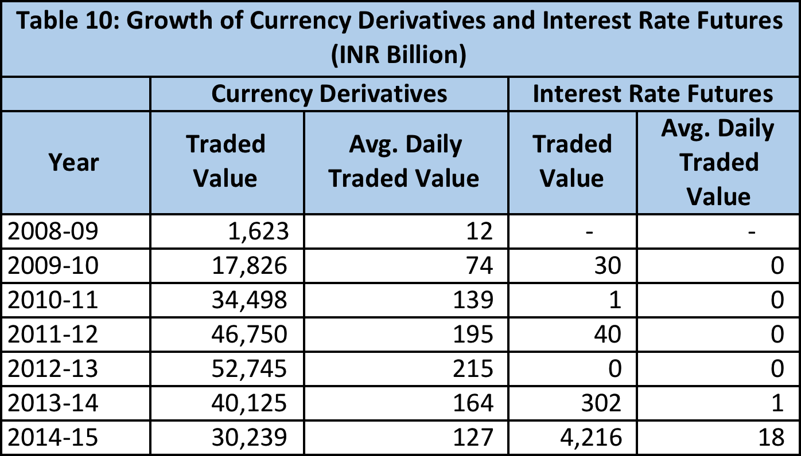
(Source: NSE)
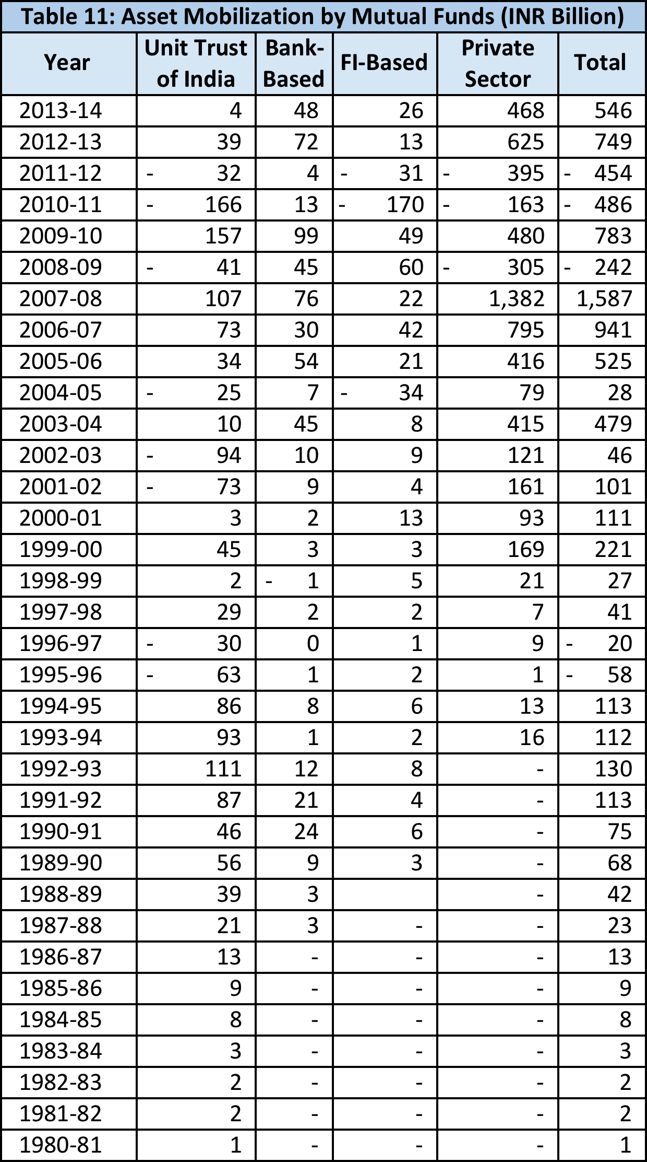
(Source: AMFI, RBI)

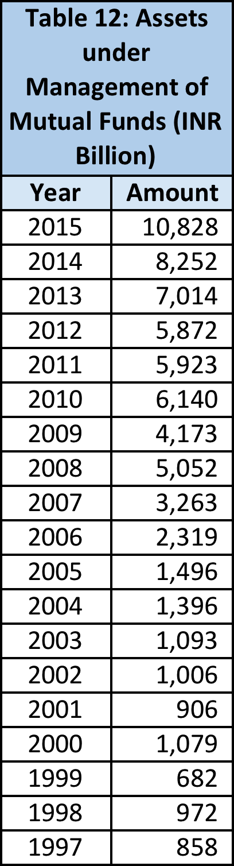
(Source: AMFI, RBI)

Sources
- RBI (www.rbi.org.in)
- AMFI (Association of Mutual Funds of India) (www.amfiindia.com)
- SEBI (www.sebi.gov.in)
- NSE (www.nseindia.com)
- BSE (www.bseindia.com)
- NCFM: Capital Markets, Debt Markets, Derivatives, Mutual Funds modules
- ‘India’s bond market – developments and challenges ahead’, Stephen Wells and Lotte Schou-Zibell, ADB Publications
- ‘A study of derivatives market in India and its current position in global financial markets’, Shalini H.S. and Ravendra P.V., IOSR Journal of Economics and Finance
- ‘Indian derivatives market’, Asani Sarkar, The Oxford Companion to Economics in India
- ‘Toward vibrant debt markets’, FIIMDA presentation
- ‘Simply put: taking a composite view of foreign investment in India’, Shaji Vikraman, Indian Express

