Monetary Policy and The Reserve Bank of India (RBI)
Table of Contents
Banker and Debt Manager to the government 2
Banker to the banks 2
Issuer of Currency 3
Monetary Policy 3
Current Goals: 3
Process: 3
Instruments: 3
Special instruments: 5
Foreign Exchange Management 5
Exchange Rate Policies in India 6
Payment and Settlement Systems 6
Appendices 9
References: 16

Banker and Debt Manager to the government
The RBI was formed under the Reserve Bank of India Act, 1934, and undertakes the traditional central banking function of managing the Government’s banking activities. Thus, the RBI manages the Central Government’s money, remittance, exchange and banking transactions, and its public debt. The RBI does not handle the Government’s day-to-day transactions, except in the case where it has been specifically nominated as the banker to a specific ministry. Currently, the Central Government is required to maintain a minimum cash balance of INR 100 million (daily) and of INR 1 billion (on Fridays) with the RBI.
The RBI also acts as the banker and debt manager of State Governments in India (apart from the state of Sikkim, where it has a limited agreement for public debt management). As with the Central Government, all State Governments are required to maintain a minimum balance with the RBI, though this limit varies from state to state (based on the economic activity and size of budget of the state).
Management of public debt: The RBI is singularly responsible for managing the public debt of the Central Government as well as that of State Governments. Its responsibilities include: 1) issue of new rupee loans (primarily through Government Securities and Treasury Bills), 2) payment of interest and repayment of principal on existing loans, and 3) operational matters such as issuing and registering debt certificates.

Banker to the banks
The RBI, as any other Central Bank, provides a central mechanism to banks in the Indian economy to transfer funds, and to settle inter-bank and customer transactions. In turn, banks are required to maintain a portion of their demand and time liabilities with the RBI as reserves, and to maintain accounts for inter-bank obligations, clearing and settlement, and for forex trading (in addition to the reserve requirements). The RBI constantly monitors the accounts that banks hold with it, and requires a minimum balance to be maintained in each of them. All activity in these accounts is routed through an electronic transfer system called ‘e-Kuber’.
The RBI also acts as a lender of last resort to banks – the Central Bank comes to the rescue of any bank that is solvent but facing a temporary liquidity crisis, by supplying that bank with emergency liquidity. The objectives behind this role are two-fold: 1) to protect depositors, and 2) to protect a bank from becoming insolvent and possibly impacting the entire banking sector.
Parallel action in the U.S.: The Federal Reserve serves as a lender of last resort through the ‘discount window’, using the discount rate.

Issuer of Currency
The RBI, along with the Government of India, is responsible for the design, production and overall management of currency notes, whereas the Government of India is the issuing authority of coins, which the RBI circulates through the country. The currency is distributed through a network of over 4,000 currency chests in various commercial banks throughout India.
- Currency Notes: Printed at four locations in India, two of which are wholly-owned subsidiaries of the RBI, while the other two are wholly-owned subsidiaries of the Central Government. Denominations: INR 5, 10, 20, 50, 100, 500 and 1,000.
- Coins: Minted at four mints, all owned and operated by the Central Government. Denominations: 50 paise; INR 1, 2, 5 and 10.
The focus of the RBI is on ensuring regular and smooth availability of currency through India, and on strengthening security features on notes.

Monetary Policy

Current Goals:
- Price Stability: in the overall backdrop of growth. Thus, the relative emphasis varies between price stability and growth, depending on the macroeconomic environment that is prevalent.
- ‘Glide Path’ for Disinflation: with the objective of 8% CPI (Consumer Price Index) inflation by January 2015, below 6% by January 2016, and 4% (+/-) 2% in financial year 2016-17 and subsequent years.

Process:
- The RBI assists the government in formulating monetary policy through its Monetary Policy Department (MPD), by incorporating views of the key stakeholders in the economy, advice of the Technical Advisory Committee (TAC), and analytics from the central bank.
- The monetary policy is operationalized by the Financial Markets Department (FMD), primarily through day-to-day liquidity management.
- The Financial Markets Committee (FMC) of the RBI meets daily to review the consistency between policy rates, money market rates and liquidity conditions.

Instruments:
The RBI regulates the liquidity in the Indian economy through the following tools at its disposal:
- Cash Reserve Ratio (CRR): Currently set at 4%, the CRR is the share of overall Net Demand and Time Liabilities (NDTL) that banks must maintain as a cash balance with the RBI. (Appendices: Tables 1, and 2-1, 2-2 and 2-3)
- Statutory Liquidity Ratio (SLR): Currently set at 21.5%, the SLR is the share of overall NDTL that banks must maintain in safe and liquid assets (government securities, cash and gold). (Appendices: Tables 1 and 3)
Through changes in the SLR (and, to a smaller extent, through changes in the CRR), the RBI can directly influence the liquidity in the system, controlling bank credit to fit monetary objectives. Additionally, the SLR (and CRR) also provide a safety net for the general population, by ensuring that banks have adequate funds to meet any solvency requirements. Banks must report their SLR numbers every alternate Friday to the RBI, and are penalized if they fail to meet the requirements.
Parallel instrument in the U.S.: Reserve Requirements – every depository institution in the U.S. is legally required to set aside a certain percentage of their deposits as reserves (either as cash or account balances with a Reserve Bank). These accounts are used by banks to process various financial transactions with the Fed (such as check clearings, electronic payments etc.) (Appendices: Tables 1 and 7)
- Liquidity Adjustment Facility: This consists of overnight and term repo / reverse repo auctions. In a concerted effort to promote longer-term monetary stability, the RBI has increasingly moved towards term repos.
- Term Repos / Reverse Repos: The rate at which banks borrow from / lend to the RBI. Currently, the repo rate is set at 6.75%, while the reverse repo is at 5.75%. The primary objectives of the repo market are two-fold: a) to improve the transmission of monetary policy, and b) to help develop the inter-bank money market. (Appendices: Tables 1 and 4)
- Marginal Standing Facility (MSF) Rate: Currently set at 7.75%, this is the rate at which commercial banks can borrow additional overnight money from the RBI (up to a limit of 2% of the NDTL in their SLR portfolio), at a penal rate of interest (100 BPS over the repo rate). The purpose of the MSF is to avert any unanticipated liquidity shocks to the banking system. (Appendices: Tables 1 and 5)
Parallel instrument in the U.S.: The Federal Reserve uses the discount rate to charge eligible financial institutions to borrow funds on a short-term or emergency basis, through the ‘discount window’. This is set above the federal funds rate and is set by the Fed’s Board of Directors (Appendices: Table 1).
The Reverse Repo and the MSF rates are instrumental in determining the corridor for short-term money market interest rates.
- Bank Rate: Currently set at 7.75%, this is the rate at which the RBI buys or rediscounts bills of exchange or any other commercial papers. The bank rate is aligned with the MSF rate and moves in tandem with it (the MSF rate, in turn, moves in tandem with the repo rates). (Appendices: Tables 1 and 6)

- Open Market Operations (OMOs): The primary objective of the OMOs of the RBI, as is the case with any central bank, is to inject additional liquidity into or to absorb excess liquidity from the system, through the purchase or sale of government securities, respectively.
Parallel instrument in the U.S.: similar to the instrument used by the RBI, the Federal Reserve uses OMOs to align the federal funds rate with the target set by the Federal Open Market Committee (FOMC). The Federal Reserve Bank of New York (FRBNY) conducts OMOs through its trading desk. Essentially, if the FOMC lowers the targeted rate, the FRBNY will buy securities in the open market, and sell them if the FOMC raises the rate.

Special instruments:
- Market Stabilisation Scheme (MSS): MSS instruments are primarily short-dated government securities and treasury bills, issued to provide the RBI with additional tools to intervene in the money market (to absorb surplus liquidity that might arise from large capital inflows). The cash thus absorbed from the market is held in a separate central government account under the RBI, and counts toward the prescribed SLR limits for banks.
- Refinance Facilities: These are used to provide liquidity to specific sectors (depending on the current policy thrust), at a rate linked to the prevalent repo rate. However, the RBI has progressively de-emphasized sector-specific policies over the past few years, since they are disruptive to the normal liquidity transfer mechanism.

Foreign Exchange Management
Prior to the New Economic Policy (NEP) of 1991, foreign exchange was heavily regulated in India, with dealings in foreign exchange payments outside India, and trade in currency notes, bullion, foreign securities and immovable assets controlled directly by the RBI and the Government of India. The NEP introduced a slew of measures that liberalized foreign exchange management beginning in 1991 and, since then, India’s external sector has grown substantially – from a build-up in forex reserves, to growth in foreign trade, India’s investments abroad and FII participation in India’s capital markets.
- Foreign Investment in India: The RBI now permits foreign investment in almost all sectors, with a few exceptions for national security reasons. Additionally, FIIs are allowed to invest in all equity securities, and in Government Securities, corporate bonds and mutual funds.
- External Commercial Borrowings (ECB): Prior to the NEP, Indian companies were heavily restricted from accessing any foreign capital, which substantially raised their cost of capital. Today, Indian companies are allowed to raise ECBs including all commercial bank loans, buyers’ or suppliers’ credit, and securitized instruments.
- Foreign Exchange Reserves Management: The Forex Reserves Management policies of the RBI are guided by the fundamental objectives of safety, liquidity and returns. To this end, the RBI invests reserves only in the following instruments: 1) Deposits with the Bank of International Settlements (BIS) and other Central Banks, 2) Deposits with Foreign Commercial Banks, 3) Debt instruments in sovereign or sovereign-guaranteed liabilities of not more than 10 years, 4) Certain permitted types of derivatives, and 5) Other instruments that are approved by the Central Board of the RBI and are in accordance with the Central Bank’s overall objectives.

Exchange Rate Policies in India
The RBI’s exchange rate policies have evolved substantially since independence (after 1947), with three defining periods:
1947 – 1975: Fixed exchange rate regime, based on the prevalent Bretton Woods system, with the INR pegged to the Pound Sterling.
1975 – 1991: Daily exchange rate movements determined by undisclosed basket of currencies of major trading partners.
1991 – : The beginning of market-driven exchange rates, in two phases: 1) Introduction of the Liberalised Exchange Rate Management System (LERMS) in March 1992, which instituted a dual exchange rate system, and 2) A single and unified market-determined exchange rate system replaced the LERMS in March 1993, leaving exchange rates free to respond to the forces of demand and supply.
Thus, over the years, the RBI has gone from a regulatory role to that of an overseer. The Central Bank intervenes in the forex market only in cases of extreme volatility and to ensure their smooth functioning. When it does, it intervenes by buying or selling foreign currencies, either directly or through Public Sector Banks.

Payment and Settlement Systems
Currently, the payment systems in India are split into three broad categories:
- Paper-based Payments
Paper-based instruments in India, which include checks and demand drafts, account for nearly 60% of the volume of non-cash transactions, but a mere 11% of the value. To facilitate these modes, the RBI has introduced two important systems in recent years: a) MICR technology for speeding up the processing of checks, and b) a Check Truncation System (CTS), which enables the uses of cheque images for payment processing, thus restricting the need for physical movement.
- Electronic Payments
  - Electronic Clearing Service (ECS) Credit and Debit schemes
The ECS Credit scheme was introduced by the RBI to handle bulk and repetitive payment requirements of institutions, while the Debit scheme was introduced to provide a more efficient method to handle periodic and repetitive collections of utility companies. Thus, the Credit scheme enables the institution’s accounts to be automatically credited on the specified value date, while the Debit scheme mandates bank branches to debit the accounts of consumers / subscribers and pass on the money to the companies.
In 2008, the RBI launched the National Electronic Clearing Service (NECS) across India, which enables multiple credits to beneficiary accounts against a single debit through a sponsor bank. Along with the NECS, the RBI launched the Regional ECS (RECS) in 2009, which is a miniature version of the NECS, enabling the same service at the regional level.
  - Electronic Funds Transfer (EFT)
The EFT system was introduced in the 1990s and enables a bank account-holder to electronically transfer funds to another account-holder with any other bank in the system. However, this scheme is no longer available to the general public, and has been replaced by the more robust NEFT system.
  - National Electronic Funds Transfer (NEFT) System
The NEFT system, introduced in 2005, is a more secure scheme to facilitate one-to-one funds transfer. The NEFT system enables near real-time transfer of funds by providing for batch settlements at hourly intervals. There are also a number of unique features in this system, the most prominent of which are: a) accepting cash for originating transactions, b) initiating transfer requests without minimum / maximum limitations, and c) receiving confirmation of the date / time of credit to the beneficiary’s account.
  - Real Time Gross Settlement (RTGS) System
The RTGS is a funds transfer system in which inter-bank transfers are facilitated on: a) a ‘real-time’ settlement, which is without any waiting period, and b) a ‘gross’ basis, which means using a one-on-one method, without netting with any other transaction. Any payments processed through the RTGS system are final and irrevocable, and have a minimum transaction amount of INR 0.2 million.
  - Clearing Corporation of India Limited (CCIL)
CCIL was setup in 2001 for banks, financial institutions and primary dealers (of government securities), to act as the intermediary organization for the clearing and settlement of trades in the government securities, call money and foreign exchange markets. Essentially, CCIL act as a Central Counter Party (CCP) in the government securities, USD-INR forex (both spots and forwards), and the Collateralized Borrowing and Lending Obligation (CBLO) markets. Additionally, CCIL provides a platform and repository for Over The Counter (OTC) products in these segments. Through novation, CCIL replaces the need for a single contract between two parties, with two contracts between CCIL and each of the two parties. Thus, all counterparty and credit risks are assumed by CCIL.
- Other Payment Systems
  - Prepaid Payment Systems: These are typically in the form of smart cards, magnetic-stripe cards, internet wallets and mobile wallets. Prepaid systems are restricted to payment instruments within the borders of India.
  - Mobile Banking System: Mobile banking permits are currently restricted to banks that are licensed in India and that also have a physical presence in the country.
  - ATMs, Point-Of-Sale (POS) Terminals and Online Transactions: Currently, there are approximately 61,000 ATMs and 0.5 million POS terminals (credit and debit card machines, and online payment gateways) in India. These are governed by a stringent set of guidelines, which mandate that funds received from a customer must be maintained by the bank in an internal account, without any direct access granted to the intermediary.

Appendices

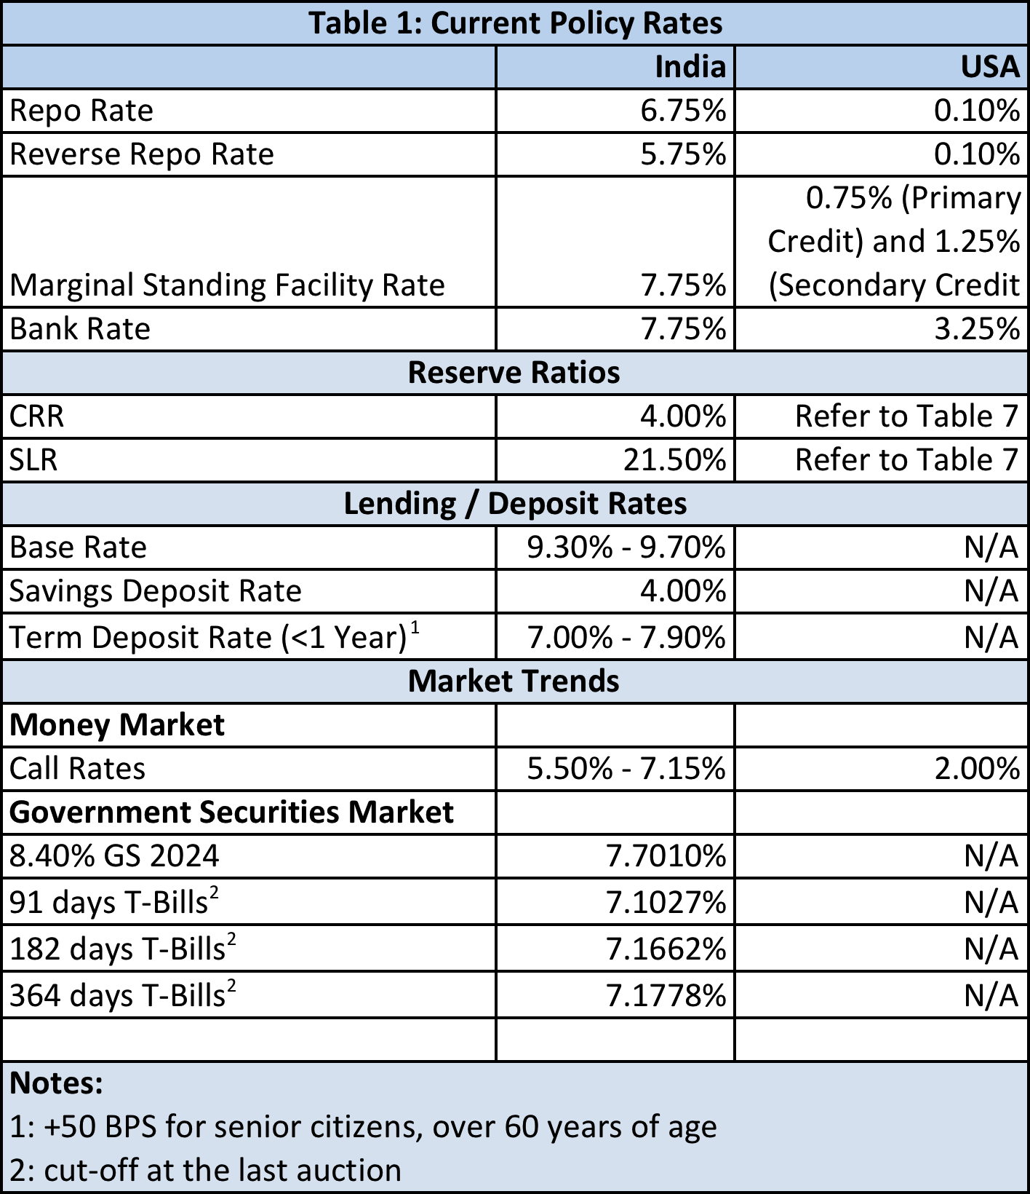
(Source: RBI, Federal Reserve, WSJ)
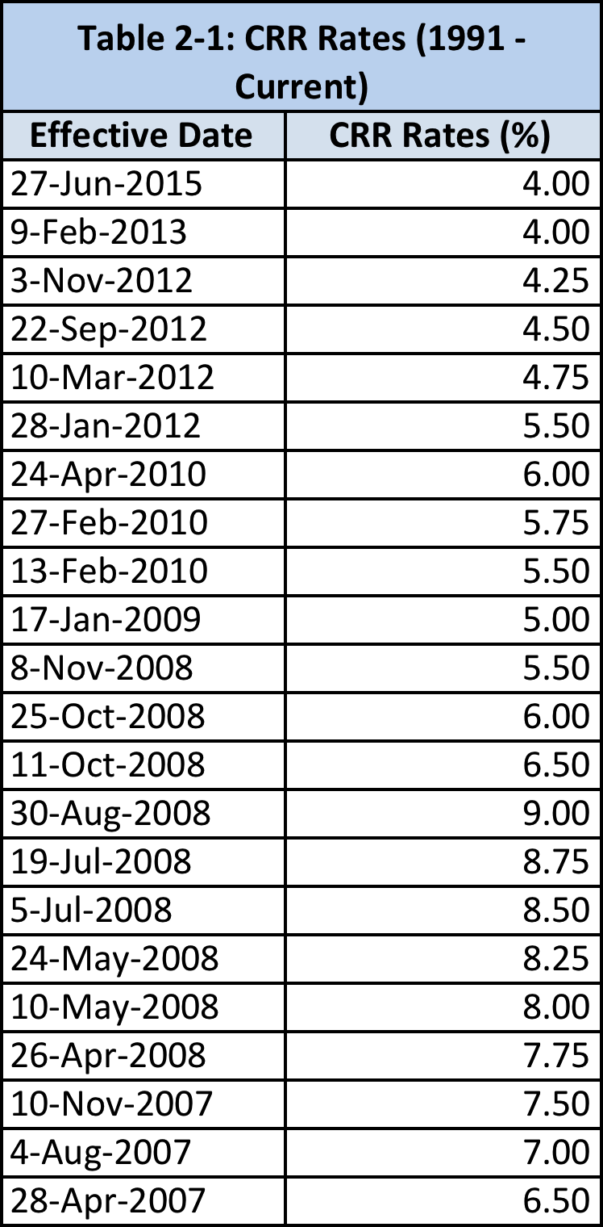 | 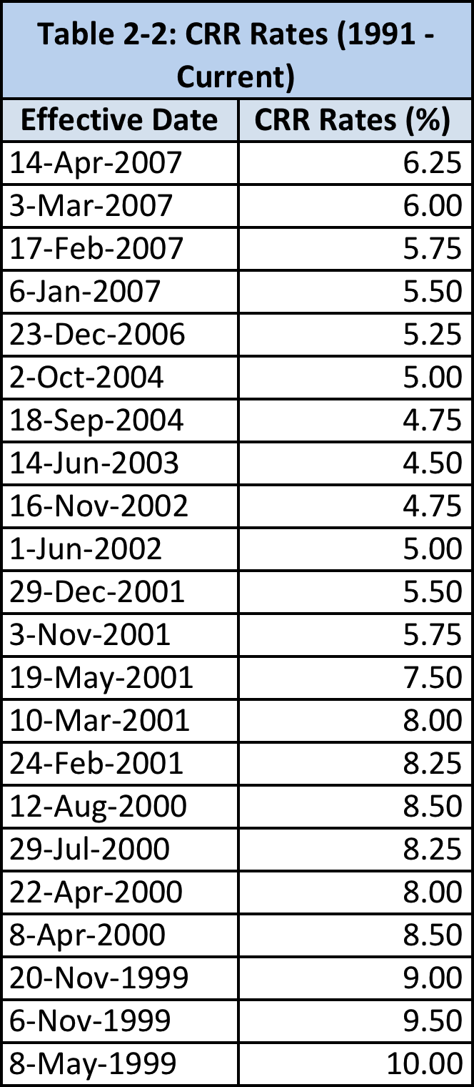
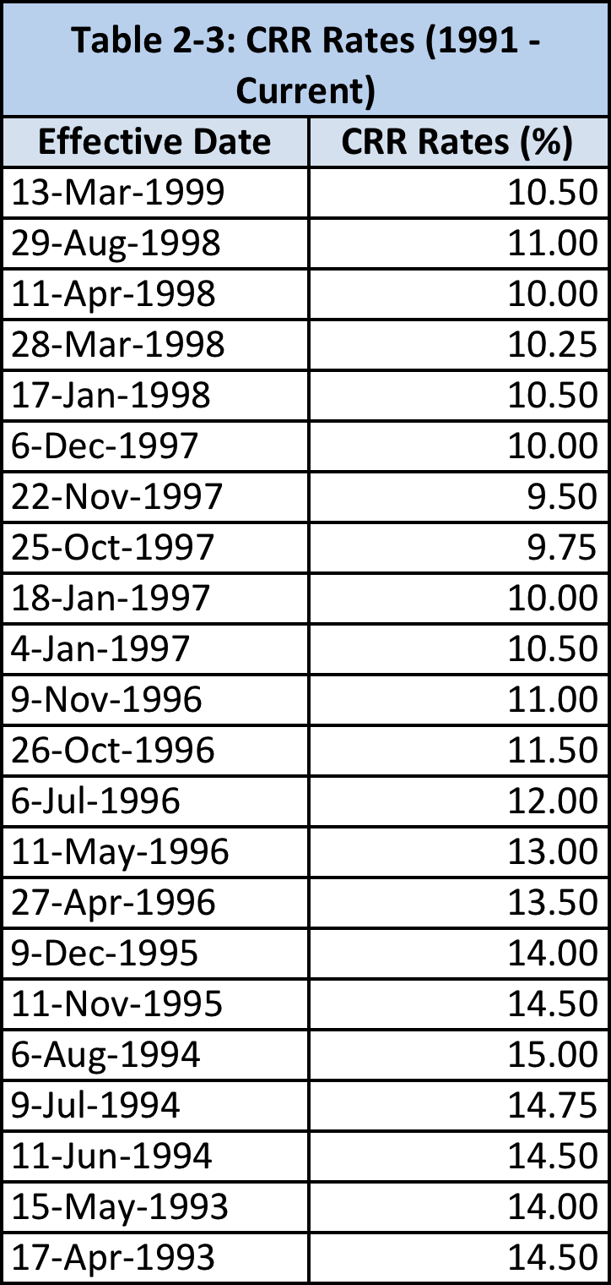
(Source: RBI)
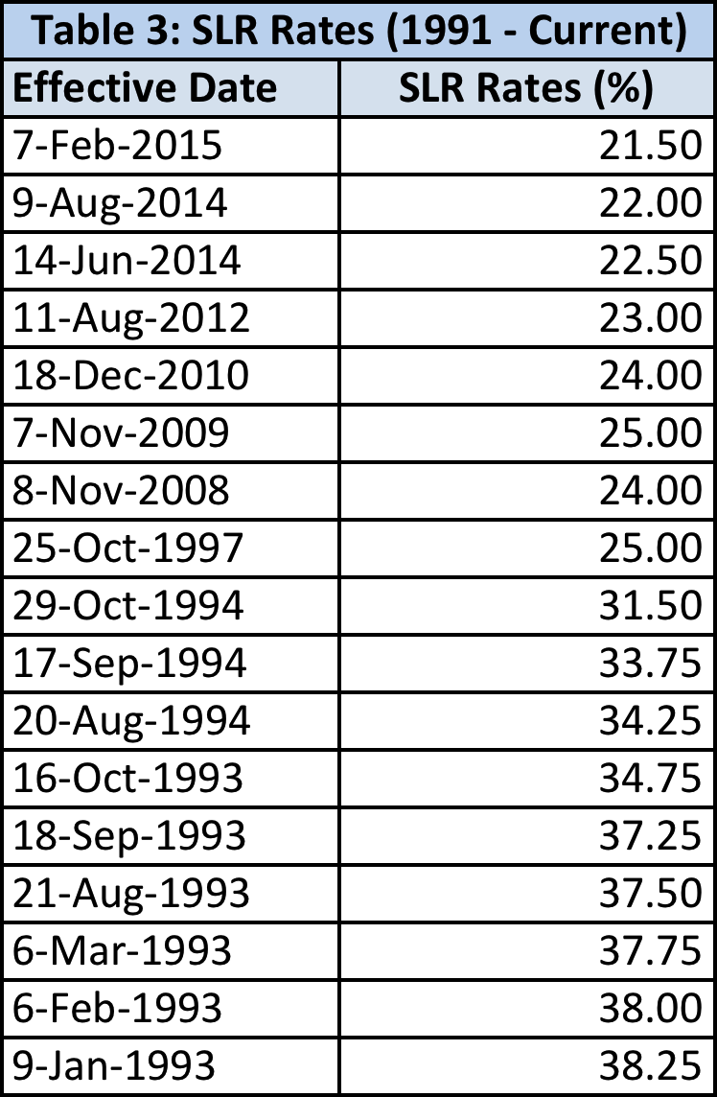
(Source: RBI)
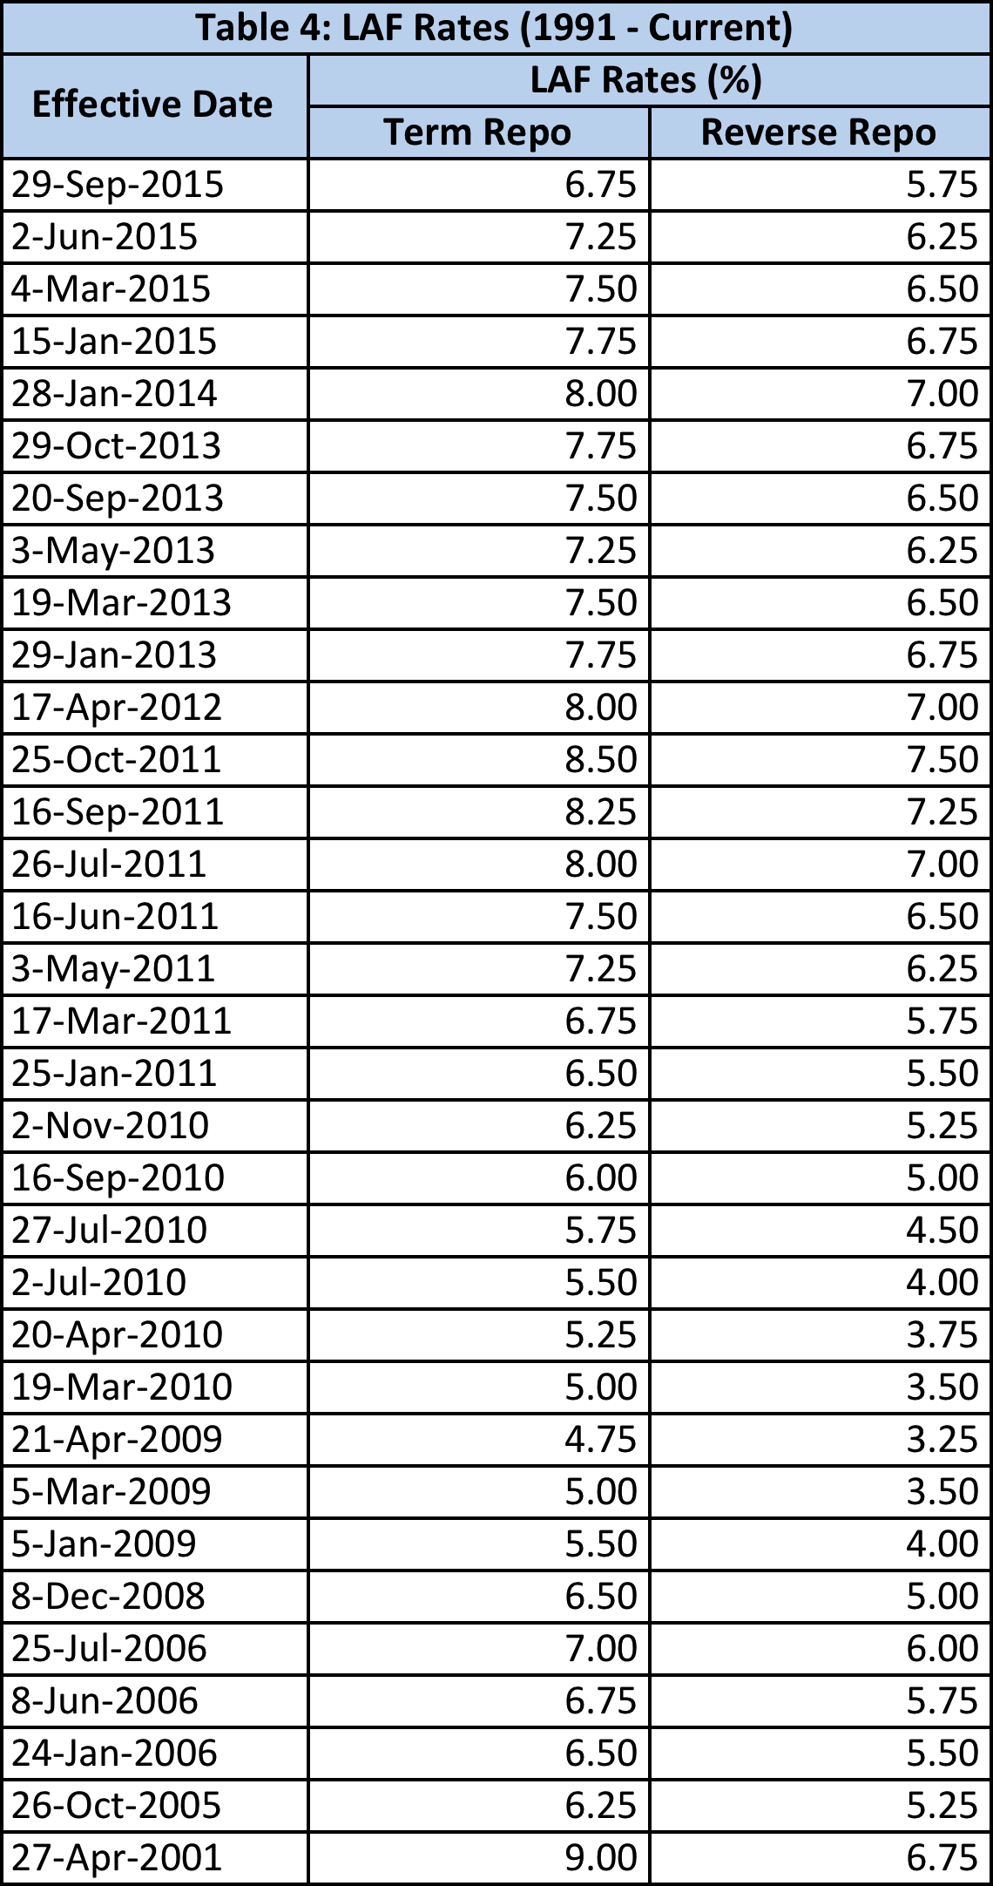
(Source: RBI)
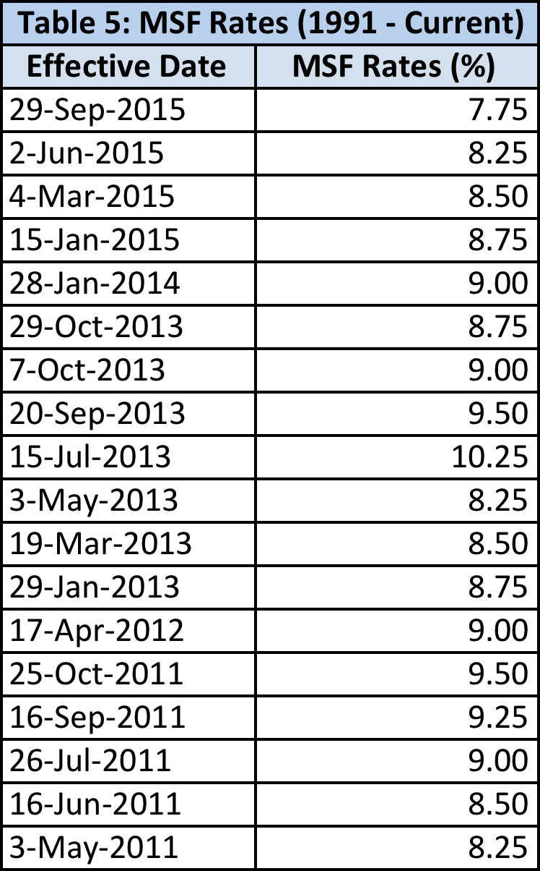
(Source: RBI)
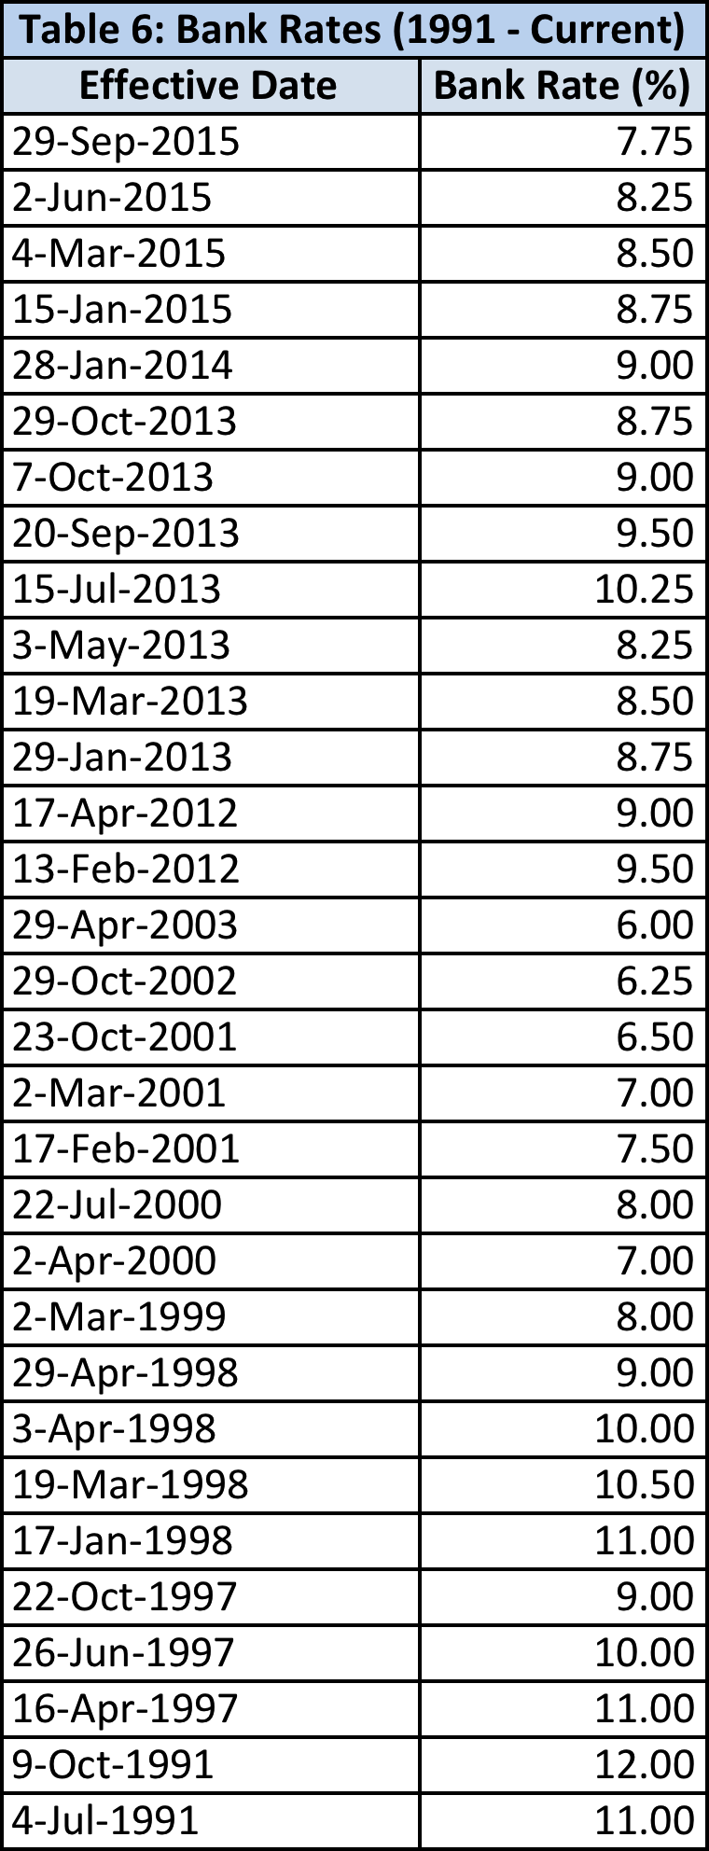
(Source: RBI)
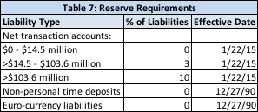
(Source: Federal Reserve)

References

- All Table data sourced from the RBI-DBIE (Database on the Indian Economy)
- RBI
- Federal Reserve
- Wall Street Journal

