Quality Progress, November, 2005
HEALTHCARE: QFD in a Managed Care Organization
by Vincent Omachonu and Paul Barach, M.D.

In 50 Words Or Less:
- Quality function deployment (QFD) provides a systematic way to translate the voice of the customer/patient into appropriate technical requirements.
- QFD, although rarely used in healthcare, can help organizations focus on their patients’ needs.
- QFD was used to help a managed care organization redesign its member handbook.
Since quality function deployment (QFD) was introduced to U.S. companies in 1983, few attempts have been made to apply it in healthcare settings. The application of QFD in the healthcare industry has been limited because the product of healthcare is ill defined and intangible. It has, however, successfully been applied in rehabilitation and dietary services1, 2, and in this instance, it was used to redesign a managed care organization’s (MCO) member handbook.
Managed care was introduced in the United States nearly two decades ago as a means to maintain quality while managing costs. An MCO contracts with physicians, hospitals, medical equipment companies and home health agencies to provide services to its members (patients). The MCO markets its services and actively enrolls people. Once enrolled, members receive a handbook that explains how they can access the services offered by the MCO and its affiliated providers.

Poor Understanding of Benefits
The member handbook has become a main source of information regarding an increasingly complex array of benefits offered by the thousands of MCOs. Designing the handbook and creating its content are, therefore, important components of any MCO’s business strategy.
Unfortunately, MCO member satisfaction survey results indicate members have a poor understanding of their benefits.³ When members are unable to understand their benefits, the MCOs’ member services switchboards are inundated with calls, resulting in frustration and anger and further delaying patient access to the MCOs’ services. The MCO discussed in this article fields an average of 3,000 calls per day, with each call lasting an average of 3.2 minutes. Approximately 50% of these calls involve issues discussed in the member handbook.
The MCO also spends more than $250,000 per year in providing supplemental materials to its members as a result of inadequacies in the member handbook. True, some members can access information via the internet; but those who don’t have internet access rely exclusively on the member handbook.
When benefits are not clearly presented in the handbook:
- Members are denied access to their pharmaceutical benefits.
- Members are denied access to their healthcare benefits.
- Providers are denied claims.
- Members are delayed in making visits to their primary care providers.
- Members are unable to access the full range of services offered by the MCO.

Can QFD Help?
QFD improves or reduces the product development cycle while improving quality and delivering the product at lower costs. Its systematic and structured approach translates the voice of the customer into the appropriate technical requirements. It offers an action roadmap for each stage of product or service development and production by connecting customer requirements to production or service requirements.
QFD’s matrix based methodology translates customer requirements into design imperatives. It creates accountability in the design process, which allows for design decisions to be traceable to specific customer requirements and technical characteristics.^{4, 5}

Data Gathering Methods
The input for the QFD process in this study was obtained through a series of focus groups. A total of 131 MCO customers participated in six focus group sessions. Participants were selected based on two criteria:
- They had to have been members of a competing MCO—whose member handbook was used for comparison—for at least two years prior to joining the MCO being studied. Information about their previous affiliations was obtained from a random list of member enrollment applications.
- They had to have been members of the MCO being studied for at least two consecutive years.
The focus group process was then administered in two stages:
- Participants were provided with a copy of the company’s member handbook and the competitor’s member handbook. Even though the participants had all used the competitor’s member handbook, it was necessary to provide them with copies to ensure a fair comparison. They were allowed to take both handbooks home for one week to look them over.
- The groups were brought together for a follow-up session that focused on data collection.
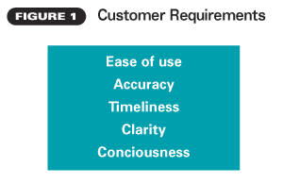

Each session was facilitated by an independent researcher unaffiliated with the MCO, and each participant was provided lunch as a reward for participating in the study.
The six focus groups all followed these steps:
- Determine customer requirements.
- Measure the importance of the customer requirements.
- Rate customer satisfaction with the company’s current member handbook.
- Rate satisfaction with the competitor’s member handbook.
- Develop a list of characteristics that are within the control of the company and could potentially improve the handbook. These characteristics are referred to as substitute quality characteristics.

Customer Requirements
The QFD process begins by capturing the voice of the customer or the customer requirements. The customer requirements are the “what” of the QFD process because they describe what the customers expect to get or need from the product or service (see Figure 1, p. 37).
These requirements are usually stated in qualitative terms and must be translated or converted into measurable technical requirements because the monitoring of these characteristics determines whether the requirements are being met. It also forms the basis of the necessary product and service design characteristics.

Technical Requirements
The technical requirements are the “how” of the QFD process because they describe how the organization will respond to each of the customer requirements (see Figure 2). They are limited to quantifiable items and are controlled to ensure customer demands are met.
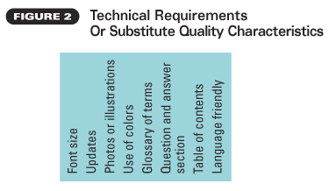

The following technical requirements were pertinent to the MCO’s member handbook:
- Adjust the font size.
- Maintain up-to-date information.
- Use pictures or illustrations.
- Use colors.
- Add a glossary of terms.
- Provide answers to frequently asked questions.
- Expand the table of contents.
- Offer the handbook in more than one language.

Strength of Relationships
The intersection between the whats and the hows defines the strength of the relationship between the two main components of the QFD matrix (see Figure 3). The entries in these cells of the matrix reflect the correlation values between the customer demands and their technical requirements. Some technical requirements may respond to a number of customer requirements, and one particular customer requirement may be addressed by a number of technical requirements.
The strength of the relationships between the customer requirements and the technical requirements are described with the aid of symbols, which provides a powerful visual impression (see Figure 4, p. 40).
After gathering the customer and technical requirements, the MCO determined there was a strong correlation between the substitute quality characteristic (technical requirement) of ease of use and the customer requirements of expanding the glossary of terms and the table of contents. Similarly, the following substitute quality characteristics had a moderate correlation with ease of use:
- Increase the font size.
- Use photos or illustrations.
- Use colors.
- Provide a question and answer section.
- Make the handbook more language friendly.
Providing updates had a weak correlation with ease of use.

Results of the Hows
The results of the MCO’s QFD study are compiled in Figure 4. The numbers or symbols in each row and column all have a specific significance.
Rate of importance: The numbers in this column indicate the relative importance customers assigned to each requirement. The importance rating is usually stated on a numerical scale from 1 to 5, with 1 being low and 5 being high. Members were asked to use such a rating scale during the focus group sessions.
Two customer requirements—ease of use and accuracy—were assigned high importance ratings of 4.5 and 5, respectively. The other three customer requirements—clarity, timeliness and conciseness—received importance ratings of 3.8, 3.2 and 2.5, respectively.
Company now: The entries in this column indicate how customers rate the organization’s performance with respect to their stated requirements. This rating is usually based on a numerical scale from 1 to 5, with 1 being poor and 5 being excellent. The MCO handbook received a performance rating of 3.2 for ease of use, 3.1 for accuracy, 3.8 for timeliness, 2.6 for clarity and 4.1 for conciseness.
Competitor X: The entries in this column represent how the customers rate the chief competitor X with respect to their stated requirements. As is the case in the company now column, these ratings are usually based on a numerical scale from 1 to 5, with 1 being poor and 5 being excellent. According to this study, the chief competitor’s handbook is outperforming the MCO’s handbook in ease of use, accuracy and clarity, as perceived by its customers.
Plan: The plan column indicates where the company wishes to be with respect to each of the quality requirements stated by its customers. The plan for each requirement is determined by examining the MCO’s position in relation to its competitor(s) and its customers’ rate of importance. It is also based on the organization’s strategic plan.
After taking all things into account, the MCO’s QFD team set a goal of achieving a performance rating of 4.5 for ease of use, 4.6 for accuracy, 3.8 for timeliness, 3.9 for clarity and 4.1 for conciseness. The MCO expects to achieve these levels of performance the next time its customers are surveyed in 2006.
Rate of improvement: The rate of improvement column contains the ratio of the company’s goal compared to where the company is today. It is determined by dividing the value in the plan column by the value in the company now column for each requirement. For example, the rate of improvement for ease of use was obtained by dividing the plan value (4.5) by the rating of the MCO today (3.2). The resulting value for the rate of improvement was 1.4. Similarly, the rate of improvement for accuracy, timeliness, clarity and conciseness were 1.5, 1, 1.5 and 1, respectively.
Absolute weight: The absolute quality weight is determined by multiplying the rate of importance by the rate of improvement. It is an attempt to assign a weighted rate to what the customer considers to be important and the goal (value established in the plan column). To determine the absolute weight figure for ease of use, for example, the QFD team multiplied 4.5 by 1.4 to get 6.3. The other values for the absolute weight ended up being 7.4, 3.2, 5.7 and 2.5, respectively. The sum of the total absolute weight was 25.1.
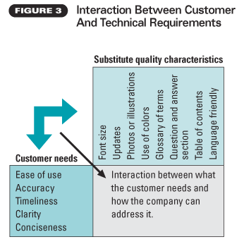

Percentage of importance: The percentage of importance was determined by transforming each absolute weight value into a percentage of the total absolute weight value of 25.1. Once the total absolute weight (25.1) value was determined, each value of the absolute weight was divided by the sum of the absolute weight and multiplied by 100 to convert each entry to a percentage. To calculate the demanded weight for ease of use, for example, the team divided 6.3 by 25.1 and multiplied by 100. This comes to 25.2%. The highest demanded weight was 29.5% for accuracy.
After thoroughly looking at what is important to the MCO’s customers, the company’s current performance, its chief competitor’s current position and the goal, the MCO determined accuracy is the most important requirement driving customer satisfaction, with nearly 30% of the demanded weight.
Keep in mind that QFD assigns a ratio of 9:3:1 for the weights assigned to the strength of the relationships in the correlation values. This is merely a rating system that allows QFD users to prioritize the strength of the relationships.

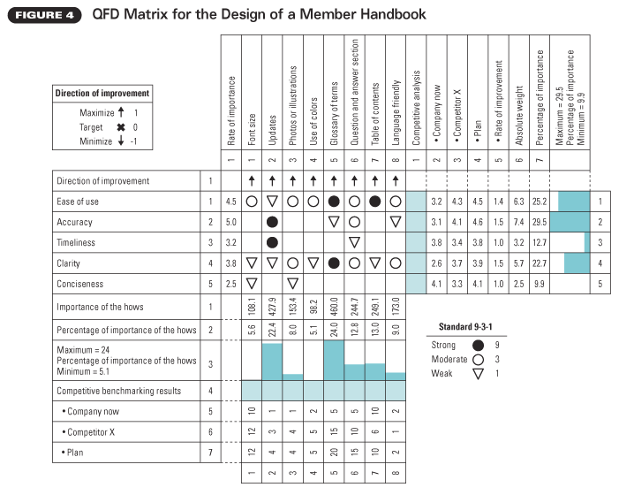

Results of the Whats
Importance of the hows: The figures in this row represent the sum of the products of each column symbol value and the corresponding demanded weight. The calculation for font size total is 3 (circle) x 25.2 (percentage of importance for ease of use) + 1 (triangle) x 22.7 (percentage of importance for clarity) + 1 (triangle) x 9.9 (percentage of importance for conciseness) = 108.1. Similarly, the totals for the remaining technical requirements are 427.9 for updates, 153.4 for photos/illustrations, 98.2 for use of color, 460 for a glossary of terms, 244.7 for a question and answer section, 249.1 for a table of contents and 173 for language friendliness. The sum of all the entries in the total row is 1,914.4.
The two most important technical requirements were glossary of terms and updates, with totals of 460 and 427.9, respectively.
Percentage of importance of the hows: Each entry in this row is divided by the sum of all the entries in that row and multiplied by 100 to convert it into a percentage. For example, the percentage for font size is calculated as 108.1/1,914.4 x 100 = 5.6%. Similarly, the remaining percentages are 22.4%, 8%, 5.1%, 24%, 12.8%, 13% and 9%, respectively.
Company now: This row gives the values of the measurable technical requirements. Table 1 shows the performance indicators for the values in Figure 4.
Competitor X: The QFD team examined and analyzed the chief competitor’s member handbook and interviewed the sales and marketing representatives of both companies to determine the values of the technical requirements for the chief competitors as shown in Figure 4. A total of four sales and marketing representatives participated in this study. They were selected based on their knowledge of and experience working with the two companies
The competitor outperformed the MCO under study in all aspects of the technical requirements, except language friendliness and table of contents.
Plan: The most aggressive plans were targeted at the two technical requirements with the highest totals: glossary of terms and updates. The plan values represent the design targets for the team’s effort for the redesign of the MCO’s member handbook.

It Made a Difference
Following the redesign of the member handbook, the volume of calls associated with the issues addressed in the handbook decreased from 3,000 calls per day to 1,900 (about a 35% reduction). Member services telephone operators were able to attend to other important issues facing the members of the health plan. Besides increasing operational efficiency, this improvement enhanced member satisfaction and reduced employee frustration in having to repeatedly deal with these issues.
QFD does have some drawbacks, however. It assumes an organization has the resources to overcome any constraints it might encounter in fulfilling the plan, and it incorporates some subjective data. All qualitative data needs to be gathered carefully and validated prior to impacting major cost and design considerations.
QFD is a useful tool for organizations seeking to redesign their products and services. Organizations routinely make changes to the design of their services and products without fully taking into account all the variables considered in the design process.
Real patient centered and patient friendly companies need to integrate this level of additional input into their redesign decision processes. QFD allows for transparency in the design decision process, making it easier to link the rationale for design changes to specific customer and technical requirements. The QFD process offers a fresh tool to help focus healthcare organizations on the needs of their pa
REFERENCES
- Y.A. Akao, Quality Function Deployment: Integrating Customer Requirements Into Product Design, Productivity Press, 1990.
- E.M. Einspruch, V.K. Omachonu and N.G. Einspruch, “Quality Function Deployment (QFD): Application to Rehabilitation Services,” International Journal of Health Care Quality Assurance, 1996, Vol. 9, No. 3, p. 42.
- “Field Research Survey Data,” working paper, Vintex, 2004.
- J.M. Kamara, C.J. Anumba and N.F.O. Evbuomwan, “Client Requirements Processing in Construction: A New Approach Using QFD,” Journal of Architectural Engineering, 1999, Vol. 5, No. 1, pp. 8-15.
- S. Sivaloganathan and N.F.O. Evboumwan, “Quality Function Deployment—The Technique: State of the Art and Future Directions,” Concurrent Engineering: Research and Applications, 1997, Vol. 5, No. 2, pp.171-182.

